3D Unity Game

**Somnambulate**

Final Report

Candidate No: 236156

Games and Multimedia Environments (G6062)

Project Supervisor: Dr Steve Huckle

University of Sussex

2021/2

**Statement of Originality**

This report is submitted as part of the requirement for the degree of Games and Multimedia Environments (G6062) at the University of Sussex. It is the product of my own labour except where indicated in the text. The report may be freely copied and distributed provided the source is acknowledged.

**Acknowledgements**

I would like to thank my supervisor, Dr. Steve Huckle, for helping me with my project and report. His support and advice is very valuable to me. Dr. Steve Huckle also advised me time planning for each phase to keep my project on track.

I would also like to thank my family and my boyfriend, thanks for your care and love during the period of covid-19.

Summary

As we all know, the current COVID-19 situation has caused significant disruption to many people and industries. The gaming industry has consequently become a popular industry at the moment, and 3D games are one of the more technical and commercially valuable projects. Unity 3D is a 3D game development tool and game engine suite that includes engine support for graphics, networking, animation, audio, and more and a powerful editor integration, well suited for developing interactive 3D games.

This project uses unity as the development platform, designing and developing a single-player horror escape game. The implementation of the escape horror game is introduced, and the development method of the game software is described. A series of tasks are included, from pre-planning of the game, searching for source material, post-implementation of the game design code, and others, leading to a complete 3D game. It also includes testing the game's features, with anonymous user feedback to share the implementation of the game's features.

**Table of Content**

1. Introduction 6

1.1. Abstract 6

1.2. Motivation 6

1.3. Background 7

1.4. Storyline 8

1.5. Project Aims and Objectives 8

1.5.1. Primary Objectives 9

The following are the primary objectives to be completed: 9

1.5.2. Extension Objectives 9

1.6. Project Relevance 10

2. Research and Related Works 11

2.1. Horror game factors 11

2.2. Mental Illness in Horror Games: Sleepwalking 11

2.3. The Scientific Explanation of Fear 13

2.4. Interactive Storytelling 13

. 13

3. Requirements Analysis 14

3.1. Requirement 14

3.1.1. Storyline 14

3.1.2. Desirable 16

4. Game Design and Development 16

4.1. Functionality 16

4.2. Script Functions and Game Objects 21

4.2.1. Game Objects 22

4.3. Game Production Technology Process 23

4.3.1. Unity 23

5. Project Method 29

Below introduces the methodology used in the production of the game 29

5.1. Agile Software Dvelopment Method 29

5.2. Compare 30

5.2.1. Waterfall model advantage 30

5.2.2. Waterfall model disadvantage 31

5.2.3. Agile software development method advantage 31

5.2.4. Agile Software development method disadvantage 32

5.2.5. Part 2 Difference 32

5.3. Conclusion 33

5.4. Sprint 33

5.5. Project plan 34

6. User Test 35

6.1. Aim 36

6.2. Methodology 36

6.3. Survey Participants 36

6.4. Data Collection 37

6.5. Feedback 40

7. Conclusion 42

7.1. Result 42

7.2. Further Work 43

7.3. Alternative Methodologies 43

8. Professional and Ethical Considerations 44

8.1. BCS Code of Conduct 44

Should be independent put code 45

8.2. PUBLIC INTEREST [13] 45

8.3. PROFESSIONAL COMPETENCE AND INTEGRITY 45

8.4. Ethical Review 46

9. References 47

10. Appendices 49

1. Proposal 49

2. User Testing Compliance Form 51

3. Questionnaire 55

# Introduction

Below introduces my project.

## Abstract

The project's overall aim is to develop a complete interactive 3D game with a horror theme, relatively complex gameplay, and the ability to educate about somnambulism within the game. Although most horror games lack a certain level of interactivity and integrity, the goal was to make a game with Artificial Intelligence as the enemy. At the same time, the player could also interact with multiple objects.

## Motivation

Since I first picked up a PSP and played the legendary game God of War: Chains of Olympus for the first time, it that blown me away. However, computers and mobile phones still have a low pixel, low resolution, 2D graphics. The PSP's giant LCD screen, the 3D stereoscopic characters built out of countless polygons on the screen, the powerful code logic, and the interactive narrative were incredible. I wish I would be able to create 3D interactive games using the same or even better technology. Other gamers could spend one day's experience and have fun with the stories that had been carefully created as game learners or even future gamers or developers. Finding details in games, exploring the ecology of the game world, learning game engines, practising building object models, and writing game interaction logic may significantly impact a project. An interactive 3D game becomes the subject of this project. However, current industry game creations, both console and mobile, tend to use striking scenery as a selling point to attract players or repetitive game content to increase their playtime. This choice will increase the sales of many games. However, It is more important that players can fully engage and experience a good story that makes them feel awestruck. With this in mind, I began to explore a wide range of game mechanics. In all categories, it is common for people to play horror games where the player's heart is racing due to the high level of emotional tension and the adrenaline rush it causes leads to a high level of mental focus. Horror games make the player more engaged and more focused on the plot and the game's logic. So, as an ideal subject, I wanted to tell a complete, exciting and meaningful story for a horror game. The player experiences the adventure as a first-person 3D interactive protagonist.

## Background

A 3D game is a kind of interactive computer entertainment presented graphically in the three dimensions of height, width, and depth [1]. It uses 3D geometry to render materials and textures on the surface of game objects [2], bringing it much closer to the virtual world than 2D games.

Due to the latest developments in computer technology and the subsequent improvement in the digital gaming industry, players typically have more expectations and requirements for 3D games. This is the reason why interactive 3D games have become the preferred choice of many game producers, for example, Red Dead Redemption 2 [3], The Witcher 3: Wild Hunt [4], and The Legend of Zelda: Breath the Wild [5].

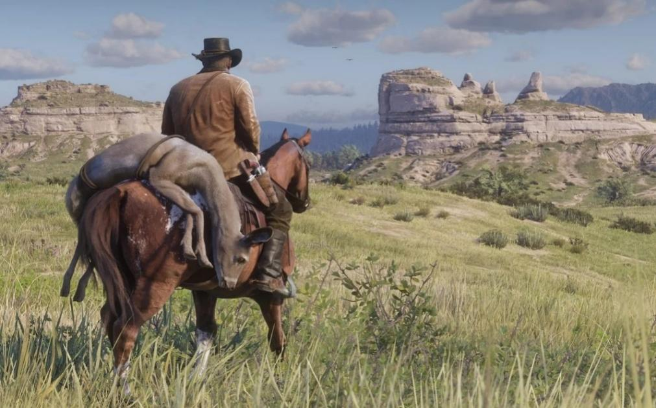

Figure 1: Main character Arthur who just hunted a fine deer riding his horse in the badlands of the Wild West in America in 1899s. <Red Dead Redemption 2>

Developing these types of games usually requires a game engine that provides the developers with various development tools and features[6]. Unity [7] is one such popular game engine.

This project and report are centred around 3D horror Interactive Games developed with Unity. Players can control their characters and explore the secrets of this virtual horror world on a map. There are plenty of horror-themed games available on the major gaming platforms, but the number of interactive horror games related to somnambulism is relatively limited.

## Storyline

Long ago, some youngsters were suffering from sleepwalking, and the people thought they were evil. So, they decided to bring the children to a witch, claiming that the witch could cure them, but in fact, they secretly killed them and told everyone that the treatment had failed, which led to the death of the children. However, the family members still knew what had happened and wanted to avenge their children. As a result, more people in the village gradually contracted the mysterious disease. Hence, people who wanted to avenge their children for not distinguishing between the virtual and the real [8] started to kill indiscriminately. Finally, escorted by his parents, the main character escaped from the village and forgot everything.

Years later, the main character returned to the horror house to cure years of mental illness. The dead spirits of the village did not intend to spare anyone who had left. They wanted the main character to stay in the there forever. However, some good-hearted spirits tried to help her escape from the village. They left clues in various parts of the village. The main character collected clues and hid from these evil spirits. She eventually learned the truth and succeeded in escaping the horror house.

## Project Aims and Objectives

3D interactive horror games require proper lighting, materials and textures, physics, animation, scripting, sound, and particle systems in the scene [9] and basic or advanced functions.

The game process should be impressive and thrilling. The game uses many horror elements to interact with the player. Nevertheless, to measure the excitement of the game, there must be enough elements that attract people to continue exploring the world in the game. In addition, the level of the game's horror (including background music, and bloody effects) needs to be adjusted reasonably based on the survey samples.

The horror genre may render some people inaccessible and cause seizures when exposed to specific light patterns or flashing lights, which very few people may experience.[10] According to a 1994 medical article, 29% of non-photosensitive patients have partial video game-related seizures.[11] Therefore, the game may try to reduce the strobe of the screen to reduce the probability of the onset of such symptoms.

### Primary Objectives

### The following are the primary objectives to be completed:

Using scenes, sounds, animations, and storylines create a scary atmosphere. For example, the sudden amplified sound effects, the echoing sound of water dripping, the eerie background music played by the ocean harp, the scenes with bright and dim lights, the shadows from far and near, the blood on the floor, Girls' whimpers and screams, dolls that produce the Valley of Terror effect, and unknown black windows in the hallway. All of these elements can give players an immersive sense of tension.

A clear guide for beginners. The tutorial contains instructions on how to win the game and the essential operation keys, such as using the mouse to view, pressing key ‘W’ to walk, holding ‘shift’ key to run, pressing key ‘E’ to interact, and key ‘M’ to view the minimap, etc.

The basic movement of the main character like running, walking, jumping, and attacking. However, the character may not have a high attacking ability, so there would be a need to create more ways of hiding to survive, such as hiding in a cupboard, hiding under the bed, closing the door to the room, etc.

Since the enemy in the game suffers from somnambulism, the related skills will be designed, and a shop will be made that fits the theme, and items will affect the life system in the shop.

This game will have a complete ending, escape or fail; if the player fails, they can start again.

### Extension Objectives

The following are the extension objectives to be completed:

Branch of the plot: different choices may affect the outcome.

The complex storyline can lead to many branches in the game. For example, the player can choose to believe some of the villagers on the way to exploring this unknown town or ignore their words, leading to either knowing the truth again or being stuck in this reincarnated world forever.

Save and read function.

Since the game is not particularly short, this function saves the main character's location, the progress of the level and the items collected, and the rest.

Achievement system: the achievement system is divided into the following categories.

Game process advancement, i.e., with the mainline of tasks to be carried out at a specific point in time to give players positive feedback achievements as a reward.

Collecting achievements: when the player collects enough specific or hidden props, the achievement will be rewarded to the player, thus experiencing the existing value of different ways of gameplay.

Special behaviour achievement: when the player interacts with the scene or non-player character in a specific or unexpected way, the achievement will be awarded to the player, bringing freshness and surprise to the player's playing process.

Special props in NPCs shop

The content open to players in the NPC store will increase or decrease in varying degrees as the game progresses. The most typical example is the 2019 NGA Game of the Year, Sekiro: Shadow Die Twice. The game's NPCs that provide store services will experience varying degrees of life and death as the protagonist's adventure progresses to cause new items, discounts, and other mechanics to appear in the store.

Creating increasingly complex levels, Players can choose between easy, medium, hard, and hellish difficulties, which correspond to the number of enemies, the speed of the enemies, and the player's health and movement speed, respectively.

## Project Relevance

The project will test my technical skills as a programmer. It also requires me to continuously test the game's difficulty and balance and meet potential user needs. In addition, I am interested in games and videos related to my horror game for some platforms, and it is relevant to the core curriculum of my current studies in games and multimedia environments.

This project will require knowledge of coding, Adobe Premiere Pro, and Unity, which will be used in the second and third-year modules. The project will also require the ability to maximize relevant learning knowledge and to extend this in a certain way. In addition, knowledge of Video Production Techniques and Game Design and Development in the Second Year module and the programming for 3D and visual effects on last the year's project will be needed. Furthermore, this project will require knowledge of research on the behavioural manifestations of the mental illness — sleepwalking disorder.

# Research and Related Works

This section below describes my research on the project.

## Horror game factors

The atmosphere of a horror game describes the mood, tone, overall style, and setting conveyed by the game or games, which usually affects the player's mood. Game atmosphere, including lighting, environmental design, gameplay, narrative, camera placement, and sound, may be added to create that feeling of unease and immersion in the game world [13].

This type of game can have a psychological impact on the player, as the horror element is usually at the heart of the game [15]. The psychological impact can be increased not only by the visual horror itself but also by a gradual process of development, especially the use of sound [14]. Suddenly heightened music or background music with an element of horror may affect the player's gaming experience. This project is related to the sleepwalking disorder, so it is important to highlight the theme in my game.

## Mental Illness in Horror Games: Sleepwalking

The dark horse at TGA 2017 was Hellblade: Senua's Sacrifice, a controversial game featuring a mentally ill character recognised by industry authorities for winning several awards, including 'Most Influential Game of the Year'. "The TGA recognises games that have a profound social impact. The TGA's awards for games have profound social significance. The previous year, TGA 2016's 'Most Influential Game of the Year' also went to That Dragon, Cancer, a game featuring a sick person, which showed that the TGA judges were very keen on such titles. Since then, more and more games on the market have started to portray the protagonist as a person suffering from mental illness and disorders. It could be seen that more and more development teams are satisfied with showing the entertainment function of games and have started to turn to more diverse and severe social topics such as human diseases. They are trying to convey universal values and humanistic concerns through games. Mental illness is considered to be a challenging and taboo subject. Compared to the treatment of physical illness, mental illness is still in its infancy - it is easy to feel the pain caused by physical illness but challenging to experience and grasp the pain and trauma of severe mental illness.

In Hellblade, Cena, a Celtic warrior woman, embarks on a thorny expedition through the Viking territories. Unlike other game protagonists, Cena has a severe mental illness. This characterisation means that the game places the player in the shoes of a psychopath. The entire world of light and sound comes from her fantasies, visions and hallucinations, forming a perceptual feast of madness and absurdity. The psychotic visions of hearing and seeing are more understandable than the average person. However, another dimension is difficult to explain that can be demonstrated through play: the 'delusions', where they connect things that the average person would not imagine and form the laws of their world. Many things considered coincidental and unimportant by the average person may have special meaning or revelation for the psychopath. It is a creative process whereby someone creates an entire world and immerses themselves in it, convinced of its reality, without realising that their senses are abnormal. giving the development of the game great scope for creativity, and many magical metaphysical elements can be added to the game in this way in a logical way. Even the memories of the game's protagonist could be combined with delusions of grandeur in the organisation of the entire game's plot to create a scripted story that is entirely self-explanatory before and after, yet surprising after playing. This approach is akin to an O'Henry ending and brings a sense of the unexpected and the plausible[17].

In horror games, the protagonist's mental illness also justifies the presence of many supernatural elements, horror stories, and monsters. In this game, I have used the mental illness of sleepwalking to develop the protagonist's adventures. Sleepwalking is the bizarre phenomenon of getting out of bed independently during sleep and then returning to sleep again. It is a neurological sleep disorder, the symptoms of which are generally walking around the dwelling in a semi-awake state. However, some sufferers will leave the dwelling or act in dangerous ways. Sleepwalking occurs in adults and is most often associated with schizophrenia and neurosis. The setting for sleepwalking in this game is: Sleepwalking is linked to a genetic family history [16], so the child and the parents suffer from sleepwalking in the storyline. In a few cases of sleepwalking, behaviour can be violent [16], so enemies in the game suffer from sleepwalking. When the player touches them, they are hurt because they are in a violent stage of unconsciousness.

Sleepwalking episodes can last from a few seconds to half an hour, with most ending within 10 minutes [16]. So the position of the enemies changes over time, and they do not attack the player when they are asleep.

In conclusion, it is difficult to describe what it is like to have a mental illness because the experience is different for each person and contains very personal and hidden emotions. It is even more difficult for the sufferer to open up and talk about it in a socially discriminatory environment out of self-protection. This is why the protagonist in this game is a sleepwalker. More importantly, this setting gives a reasonable explanation for many of the elements of the game. It gives the player a greater sense of immersion and allows them to become one with the protagonist and experience their adventures from a unique perspective. It also gives the player a better understanding of the real-life plight of a person with mental illness, which triggers empathy and reflection.

## The Scientific Explanation of Fear

Scientific research suggests [18] that anxiety comes before fear. For example, anxiety is always the first thing we feel in video games. If fear is a reaction to an imminent threat, then anxiety is a reaction to a potential future threat.

Humans have a sensory system, and according to research, when danger is slowly approaching, humans develop a sense of anxiety and heighten their attention and sensitivity to this potential danger. When the player is in a tense situation in a game, such as dim lighting, limited vision, and infinite darkness, they feel the danger. According to many players' statements, their fear rises when solving puzzles in a dangerous environment.

When confronted with these environmental cues, they simultaneously feel fear and danger. The environment plays a critical role in perceiving fear and enhances the reaction to the surprise. Our basic sense of fright will gradually change as the aversion condition acts (against the player) in the right environment. The environment acts both inside and outside the game. Outside the game, the atmosphere enhances the player's experience (like in a dark room, playing with headphones makes the player feel immersive). Creating the right environment inside the game is also essential and effectively uses human neurobiology. Our fear of the dark, for example, stems from an evolving day-night rhythm, where the cycle of day and night makes us vulnerable at night. Similarly, nocturnal animals such as rats often exhibit a similar startle response when they see the light.

## Interactive Storytelling

## The game features a storyline with a horror background, and this project combines the background of the game with the actual gameplay and the corresponding interactive elements. For example, Sea of Thieves, an action-adventure video game, uses a video narration of the game's opening credits to tell part of the plot and adds a story mode in which the story is triggered by conversations with NPCs and finding key items. Another example is Overwatch, a team-based action game that uses extra movies and in-game character-to-character eggs to give players a sense of the game's plot. Indie games can be completely gameplay-oriented experiences that do not focus on storytelling or characters published by [Mata H](https://search.informit.org/doi/abs/10.3316/informit.968161944145873)[19] . For example, the current version of Gunsmoke Reborn, despite the lack of storytelling, does not detract from the gameplay for a shooter. But for a horror game, the plot can largely influence the player's experience. The project, therefore, chose to add a subtitled video narration of the game's plot, which tells the plot summary and leads the player to collect inventories and add descriptions to these inventories to deepen the player's understanding of the plot. At the same time, in-game NPCs also give the player clues to help complete the plot description.

# Requirements Analysis

The project is an independent 3D interactive game designed and created as a virtual game world. The game's primary focus is for the player to control the character and explore the virtual game world to release psychological stress by playing a horror game, available to any user over 18 who may be interested in this experience.This section focuses on the game requirements.

## Requirement

The game shall reduce non-developer-designed distractions or challenges to provide a higher, more profound experience [6]. Detailed requirements are below.

### Storyline

The game shall process should be impressive and thrilling and uses many horror elements to interact with the player.

1. Scene

The game shall contain a suitable horror house containing a number of rooms and furniture, with a dense forest outside.

1. Audio

The game shall contains a variety of sound effects such as main screen music, story background music, player walking, heartbeat, running and enemy appearances. These sounds need to be adjusted in the main menu.

3.Light

The game shall contain Scenes with different types of light, dim interior lights, dim scene lights, fires in fireplaces, light in oil lamps and other lighting to match the game scenes.

4.Animation

The game shall contain animations for player and enemy, respectively, and write the appropriate code.

5. Player

Creating walking, running, standing, and death animations.

6. Enemy

Creating walking, attacking, and standing animations.

7. The game shall allow the player using the mouse to view, press key‘WASD’ to walk, hold the ‘shift’ key to run, pressing key ‘E’ to interact.

8. The game shall provide players with a tutorial and a guide to the objectives of the game.

9. The game shall have stationary enemies which can cause damage to the main character to reduce his health when the player approaches.

10. The game shall allow the player to interact with doors in the scene.

11. The game shall allow the player to use a flashlight to illuminate the scene and press ‘F’ to control the torch on/off.

12. The game shall end in two situations, defeat when the player's health value is reduced to 0 or victory when he reaches a specific location.

13. The game shall have the main menu containing the start, option, end function, and pause menu, which can help the player pause or exit the game.

14. The game shall have the loading page; it shows the loading bar and some game suggestions to help the player.

15. The game shall have a subtitled video introducing the background of the story,

16.The game shall allow the player to explore the room and find clues that can be viewed.

### Desirable

1. The game should allow fog to be dispersed across the map, marking areas the player has already visited and areas not yet explored.

2. The game should allow the player to manually save their progress at any time to repeat the game at the player's preferred point in time or location.

3. The game should allow the player to automatically save when they reach specific progress, time or location so that they can respawn when carrying out major decisions such as plot branches and challenging bosses.

4. The game should allow the player to display a small map in the HUD interface, which provides real-time feedback on the player's location and map information.

5. The game should allow the player to pick different difficulties and give the player different movement speeds, according to the various challenges.

6. The game should allow the player to upgrade their skills as the game progresses to facilitate a better escape from enemies.

7. The game should include features that would encourage the players to clear the game multiple times to experience different plot branches of the whole story, which gives players a reason to play again even after completion.

# Game Design and Development

Below introduces game mechanics and the production method.

## Functionality

This section focuses on the content of the game and the related features.

1. Main Menu

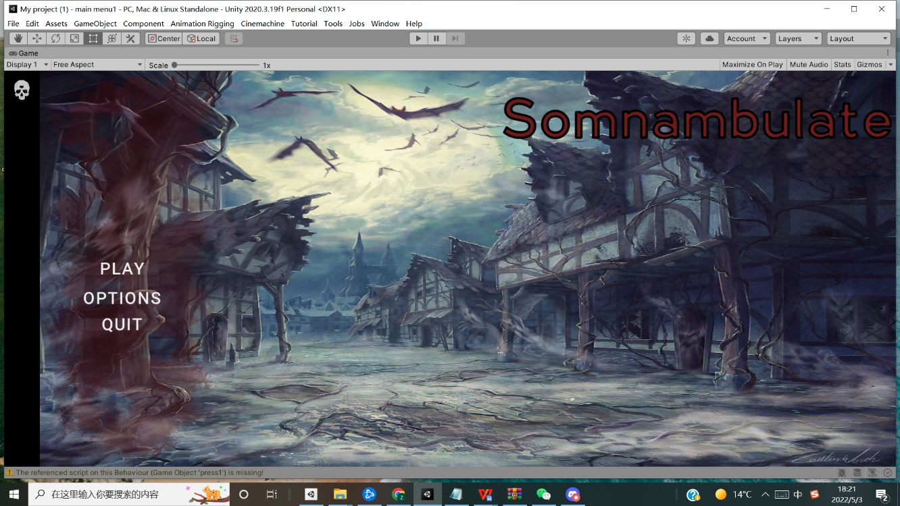

Figure 2: Game main interface

The main menu is designed with three buttons. Clicking the PLAY button will load it into the loading screen.The player can press the OPTIONS button to go to a new interface, where they can select the picture quality to switch between high, medium and low quality, drag the slider to control the soundtrack size, use the BACK button to return to the main interface and press the EXIT button to leave the game.

1. Loading Screen

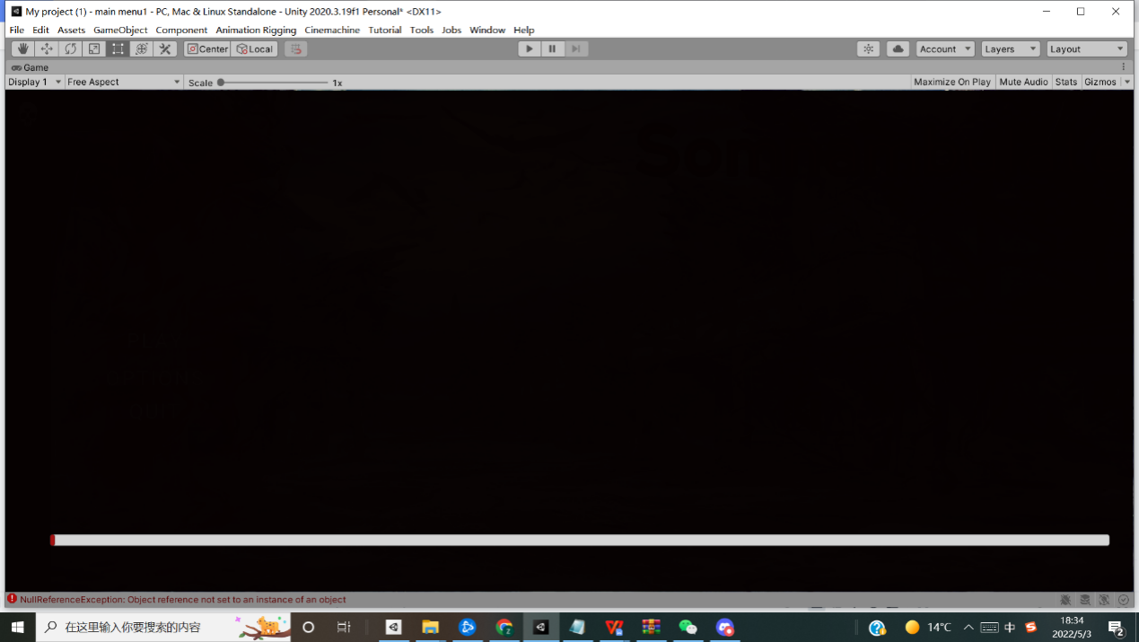

 Figure 3:Loading screen interface

When the player chooses to play the game, the loading screen will start to load, When the loading slider reaches the end of the right-hand side, it will jump to the next scene.

1. Story System

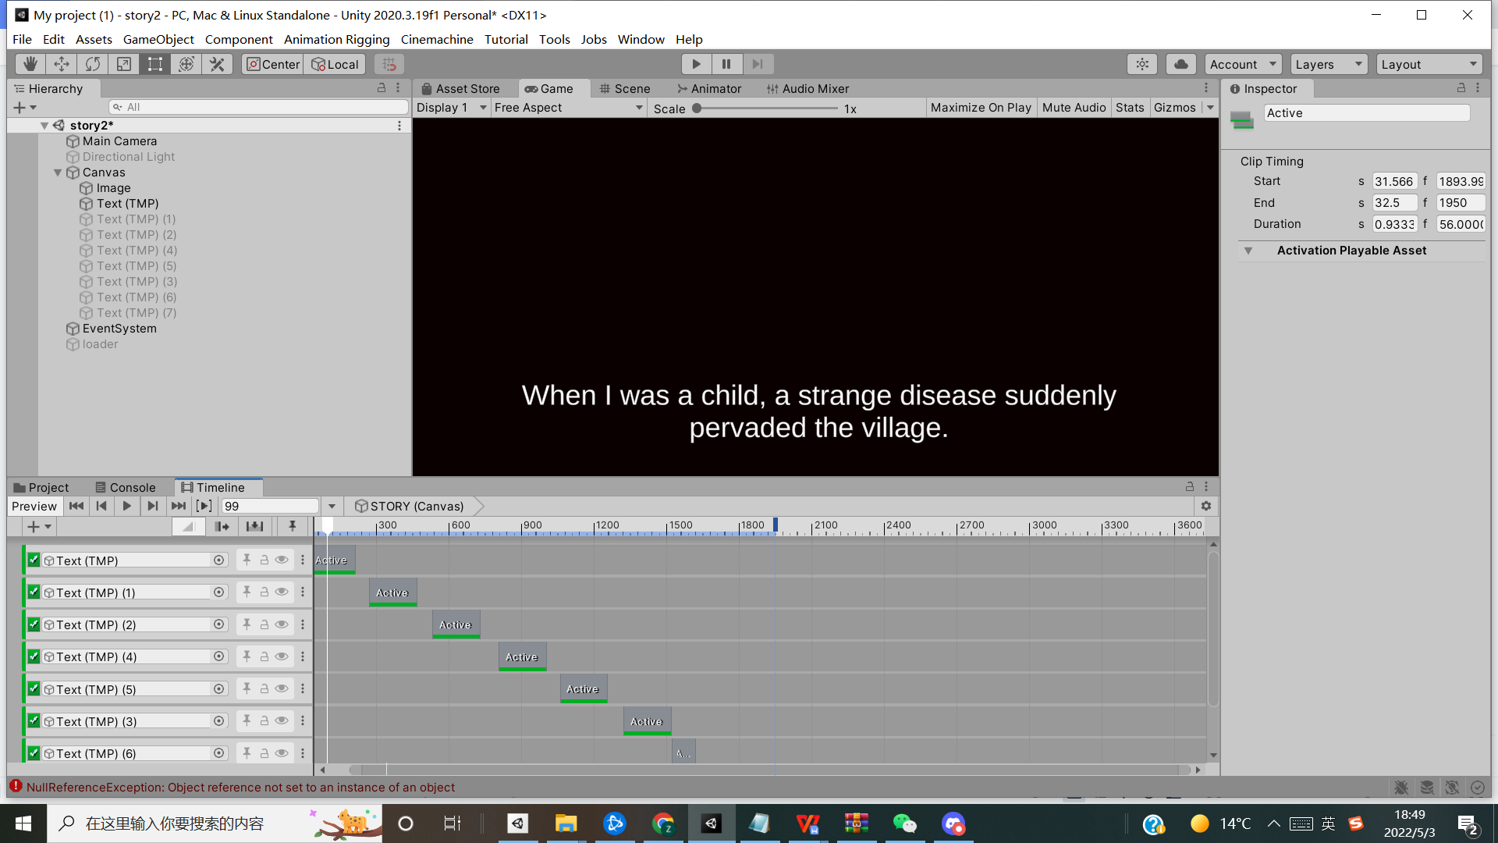

 Figure 4:Story system interface

After the loading screen, the player will skip to the story page, which will automatically play the game's story in the form of subtitles and load to the next page at the end.

1. Life System

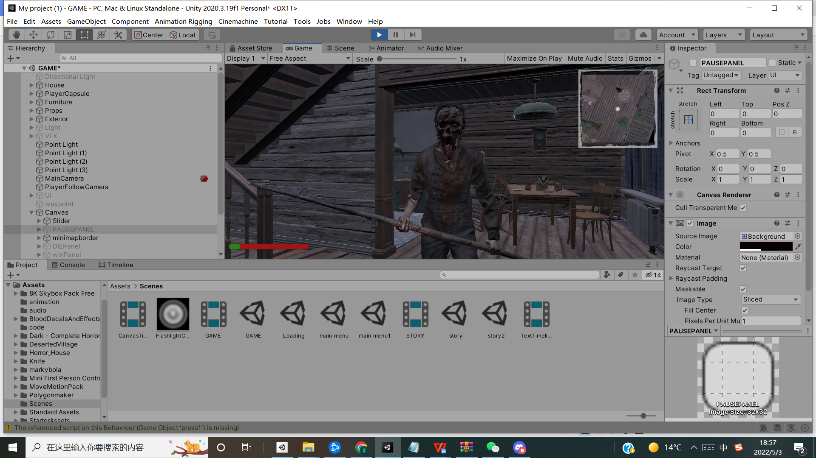

   Figure 5:Life system interface

The health system is introduced to indicate that blood and life remained in character. The initial value of the life is 100 and will decrease when the character is attacked.

1. Chasing System

An artificial intelligence chasing system is introduced for enemies to chase down player-controlled characters. Initially, they stays at its home position, and if it detects the character appearing at a certain range and angle from it, it starts to chase the character automatically. If the distance between the chasing enemy and the character gets closer, the enemy starts to attack the character until the player dies or the player leaves the current floor. Due to the enemy setting, if the player does not move after being attacked, the enemy will sleep and stop attacking and wait for the player to move and attack again.Enemies don't leave the house and enter the room on the left side of the second floor; if they encounter these positions, they will return to their initial position and orientation.

1. Pause Menu

When the player presses ESC the game pauses, press ESC again, and the game returns to the original screen.

1. Dialogue

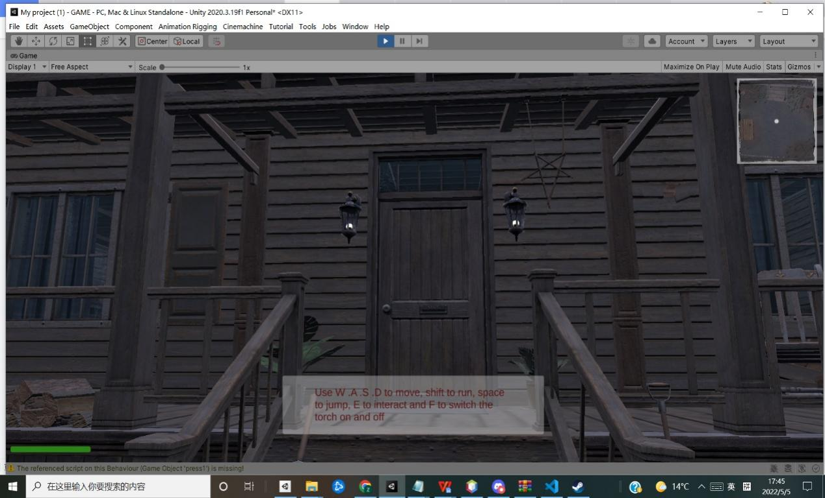

   Figure 6:Dialogue interface

 At the beginning of the game, a tutorial will appears about the game mechanics and game operation buttons, the player can press the left mouse button to read the relevant content and close the dialog box.

1. Game over Conditions

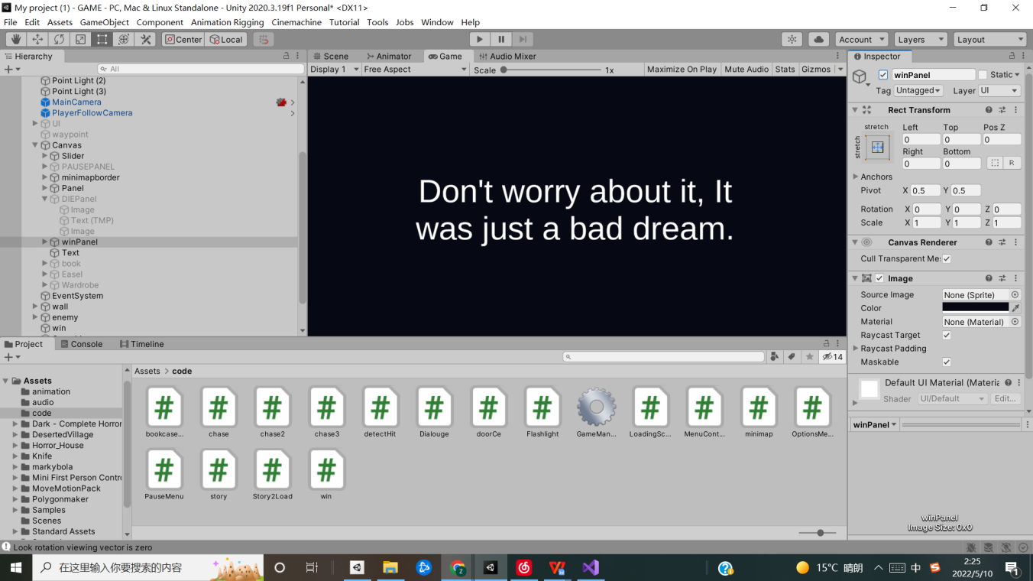

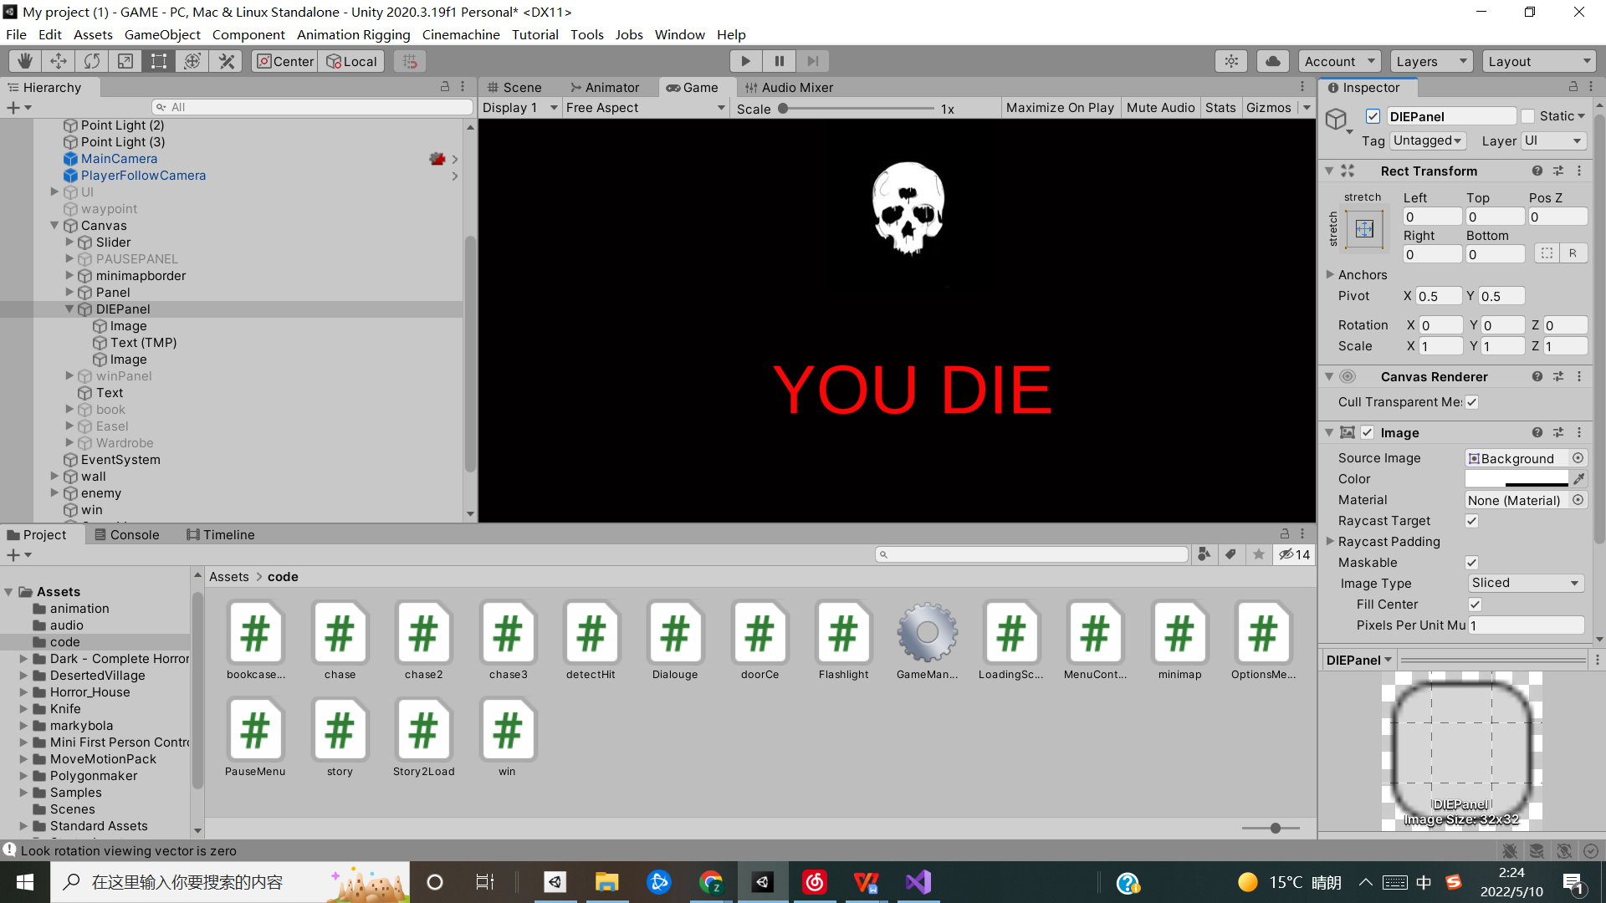

*Figure 7:Game Failure  Figure 8:Game winning*

When the player's blood level is reduced to 0 after receiving an enemy attack, the player dies, and the game ends. When the player reaches the designated location, the player wins, and the game ends.

1. Interactive System

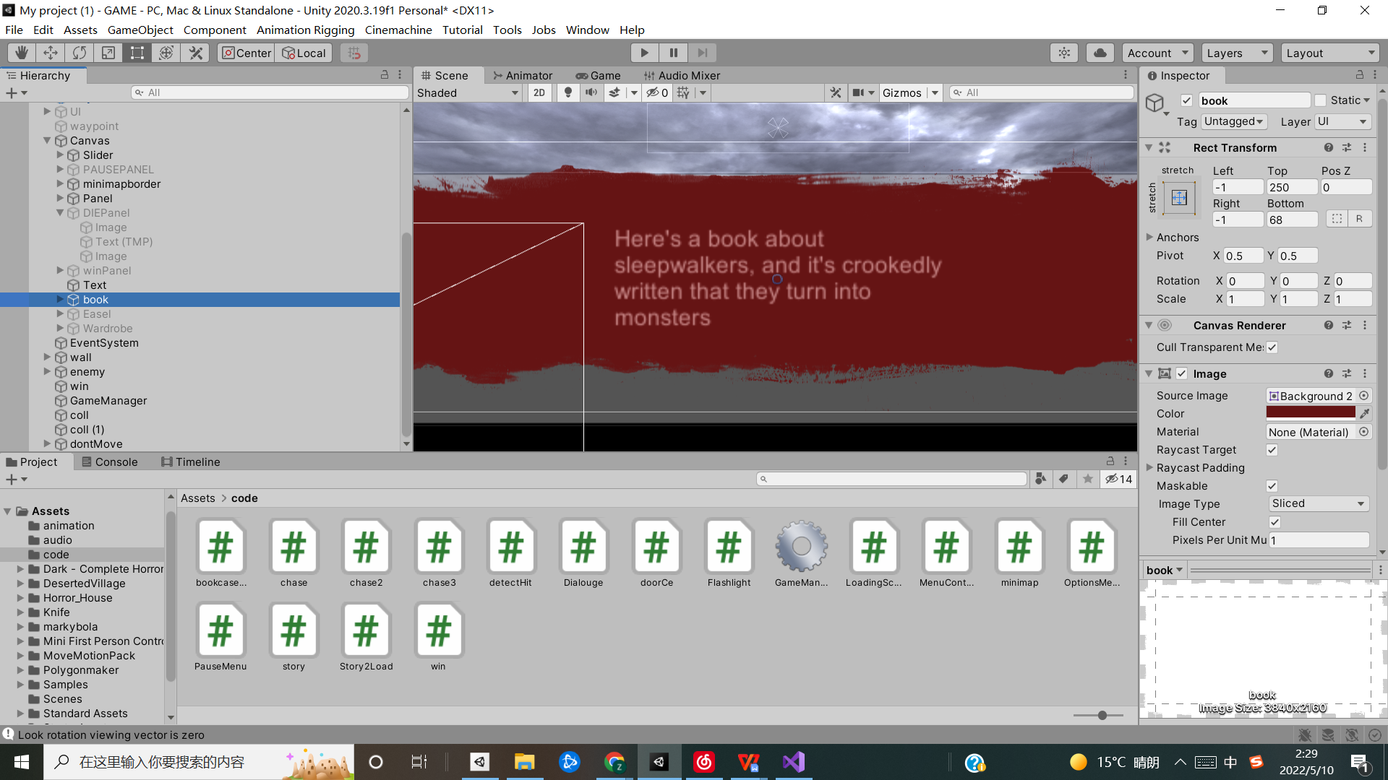

*Figure 9:Game winning*

Clues are triggered when the player encounters different objects, which are used to reveal the plot of the game and to suggest victory conditions. When the player moves away from these objects the clues will disappear automatically.

1. Minimap

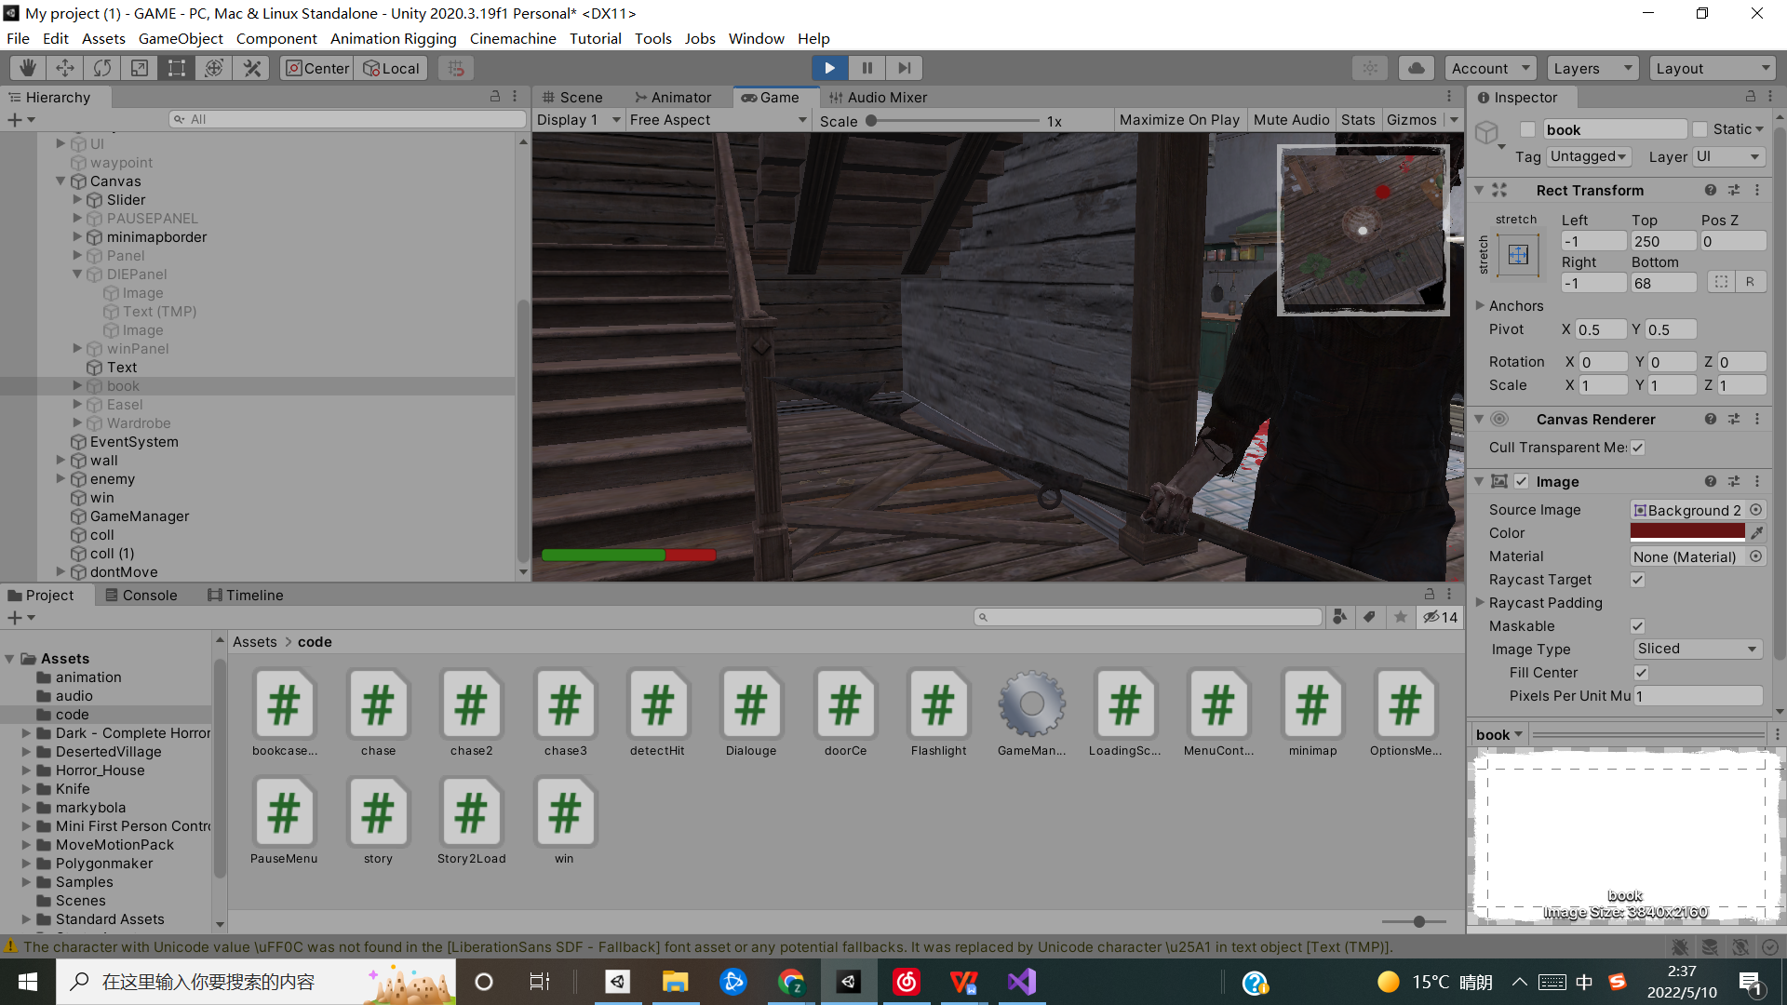

*Figure 10:Minimap*

The player can see the game mini map in the top right corner of the screen, the white circle is the player and the red circle is the enemy, in different floors the mini map display is different, the player can use this function to avoid the enemy in advance.

1. Others

The game has set boundaries that the player are not allowed to cross.

## Script Functions and Game Objects

This section introduces the two main characters of the game and also explains the corresponding code and techniques.

### Game Objects

1.Survivor

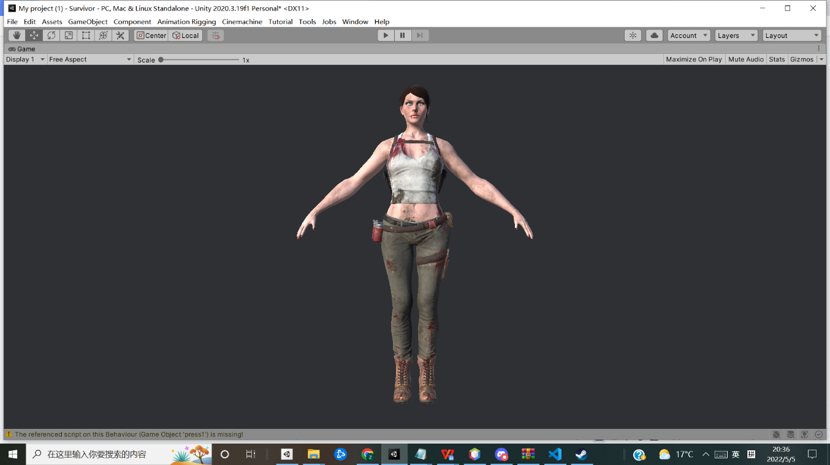

*Figure 11:Player*

The player has an initial life value of 100, a walking speed of 3, a running speed of 4, and a jumping distance of 1.The player needs to find clues and then reach the designated location.

1. Enemies

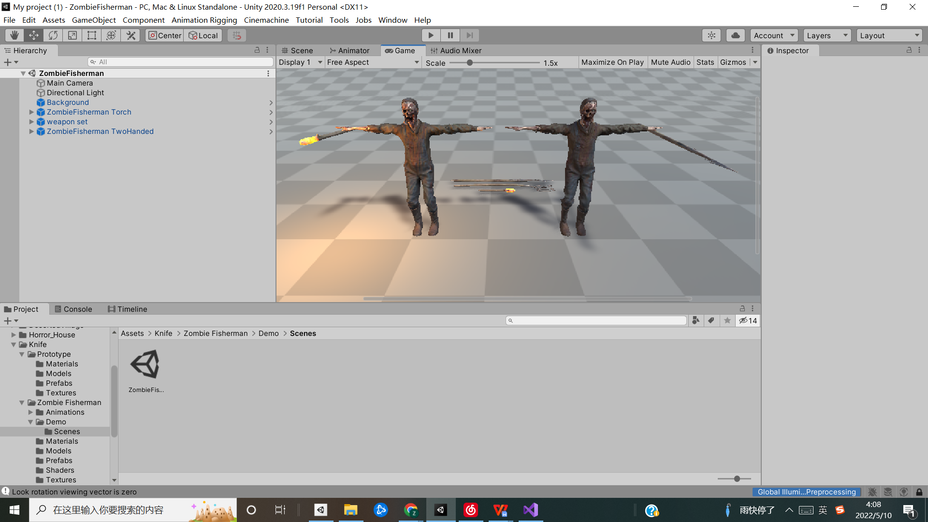

*Figure 12:Enemies*

The enemy's goal is to ambush and attack the player until the player appears in a specific location or angles, the enemy will return to the original location, the attack damage is 30 per attack.

## 3.Game Scenes

There are three scenes in the game. The first scene is the main menu; the player can interact with the UI to enter the next scene through the start, the next scene is mainly storytelling to introduce the player to the plot, and the last scene is the main scene of the game, the player will achieve the goal or die in the game until the end of the game.

## Game Production Technology Process

### Unity

Unity3D is a comprehensive multi-platform game development tool developed by Unity Technologies that enables creators to easily create interactive content such as 3D video games, architectural visualisations, real-time 3D animation and other types of interactive content. Moreover, it is a fully integrated professional game engine.

Unity naturally has its irreplaceable advantages as a popular development tool worldwide.

Firstly, Unity helps developers with various development tasks through a visual programming interface and efficient script editing, which dramatically increases development efficiency. Secondly, Unity supports automatic import. Most 3D models and even skeletons and animations can be directly imported into the engine. Also, the underlying support for OpenGL and Direct11 makes the whole development process easy and realistic with a practical and straightforward physics engine and high-quality particle system. Finally, Unity also supports various scripting languages such as JavaScript and C#.

From the above features, we can conclude that the advantages of Unity over other engines are.

1. Simplicity and speed

With Unity's simple user interface, developers save much time in their work.

2. Graphical power

Unity has a highly optimised graphics rendering pipeline for DirectX and OpenGL.

3. Resource import

Unity supports all major file formats and works with the most relevant applications.

4. Shaders

Unity's shader system integrates ease of use, flexibility and high performance.

5. Terrain

Unity's low hardware requirements allow even low-end hardware to run smoothly in vast, lush vegetated landscapes.

4.3.2 Comparison with Unreal Engine

For comparison purposes, I will also compare Unity with Unreal Engine, another well-known engine in the industry.

The Unreal Engine is a source-code available game engine, usually developed in C++. Unity is a game engine that uses C# and is cross-platform. Both engines have a large and active community of users. However, Unity 3D is already available in Unreal 4, and it has a much larger client and user base. Both tools have good graphics, but Unreal is superior to Unity due to the quality of its graphics. In addition, Unreal supports faster rendering, making post-processing quicker. On the other hand, Unity renders very slowly, and therefore projects are processed slowly[20].

Although Unity has advantages and disadvantages compared to other good engines in the industry, Unity is still an excellent development tool. Its most significant value is that it helps developers of all kinds to do their work most efficiently and conveniently possible and with great results.

4.3.2 GUI

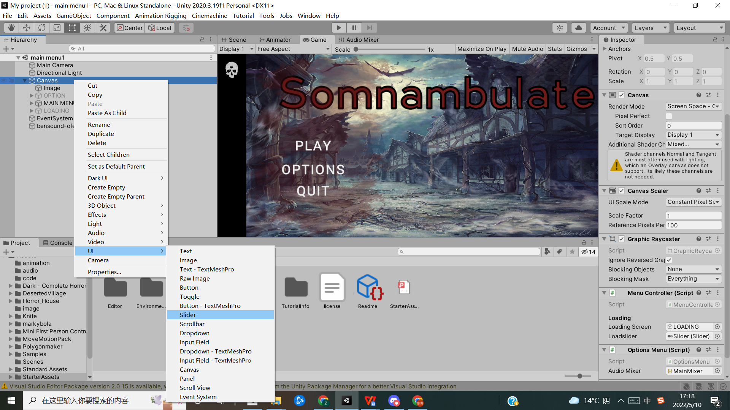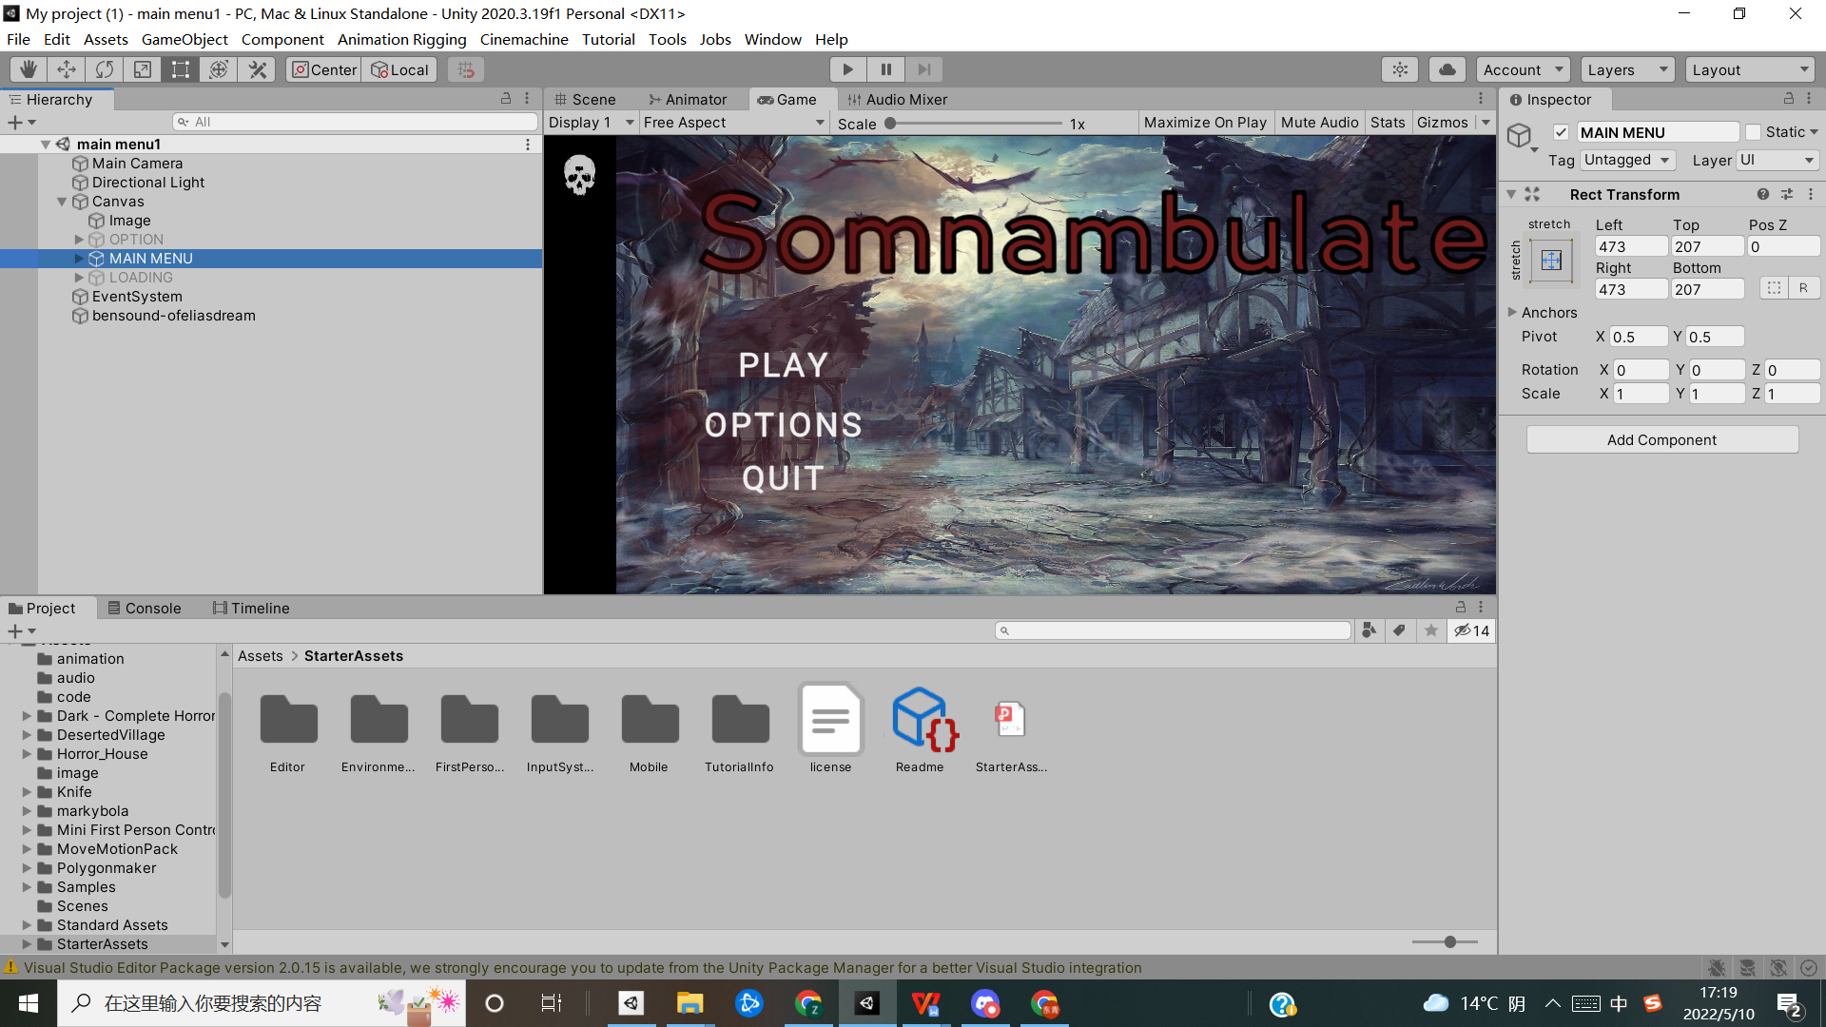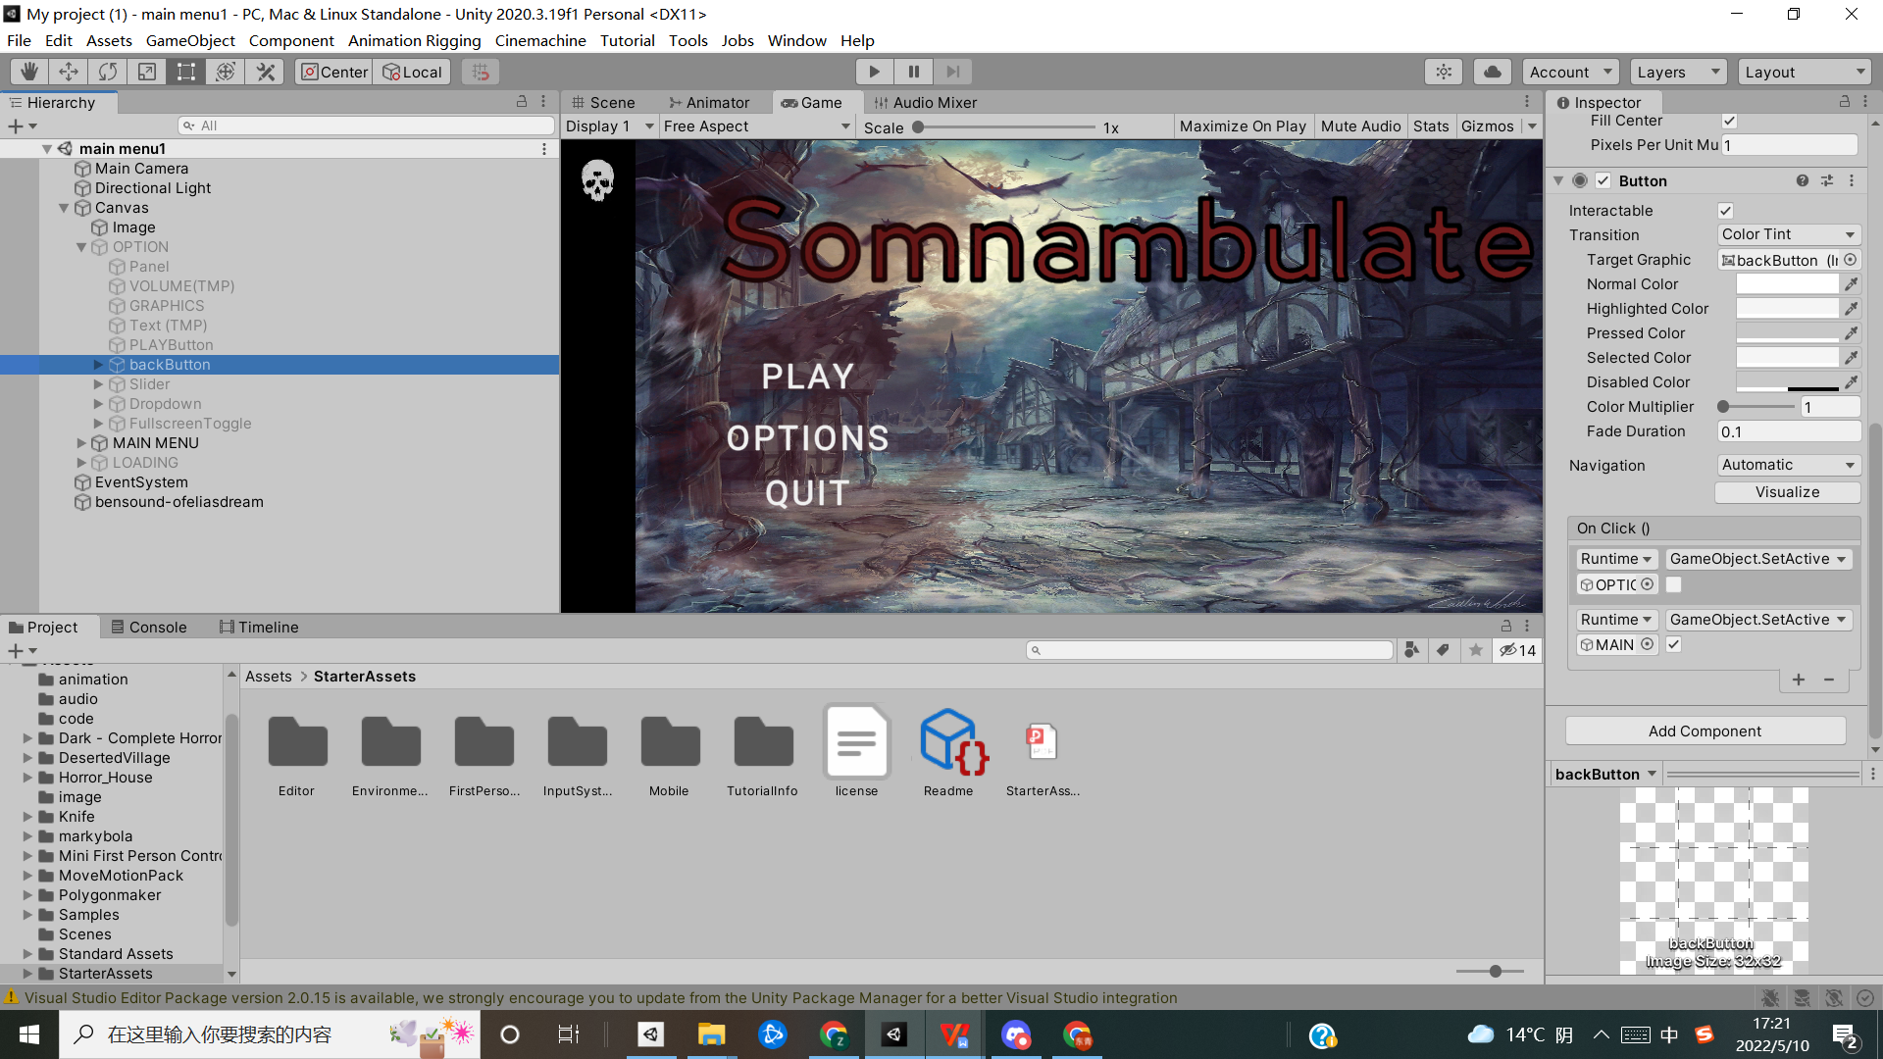

*Figure 13:GUI*

The GUI is an integral part of the game's composition, with many of the game's actions controlled directly through the UI. No matter how much the image captured by the camera changes, the GUI is always displayed on the screen, unaffected by information such as distortion, collisions, and lighting.

Canvas: The canvas of the UI under which our UI images are rendered.

EventSystem: The UI's event system controls the actions of the buttons.

Several UI elements are used in this project, a slider is added as the loading screen progress bar and player's blood bar, a panel is added as the option cleanser, and a button is added as the game button.

The RectTransform component of the UI covers position, rotation, scaling, and anchor points. The function of this component is to help the UI zoom in and out and change position angles.

The Button interaction method is shown in the diagram. The designer can use the system's methods, such as game.Object.SetActive, or by dragging the code's game object and selecting the corresponding code function.

4.3.3 Timeline

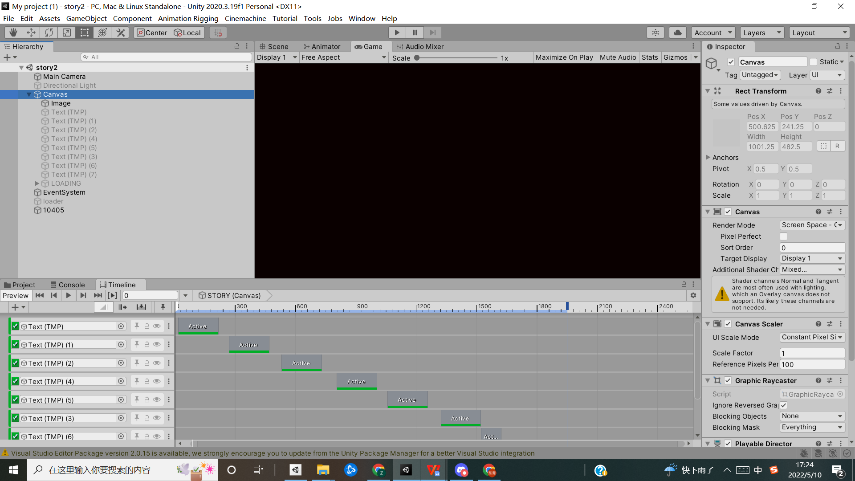

*Figure 14:Timeline*

Timeline is Unity's 2017 cinematic sequencing tool that helps designers to more easily edit action, sound, events, video and more in their films. plotting and storytelling, speeding up the production process.

In this project the timeline is used to narrate the plot by dragging and dropping the created text, audio and java script into place and changing the duration and interval.

4.3.4 Animator

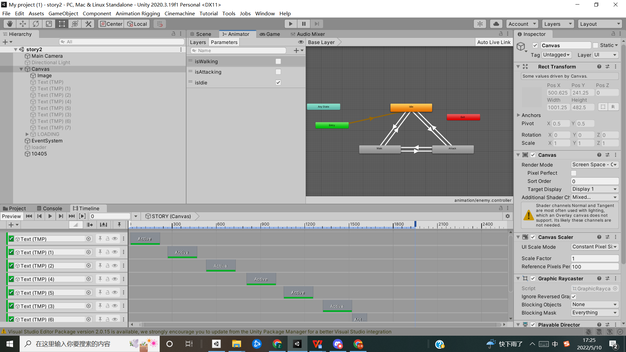

*Figure 15:Animator*

The animator is unity's animation state machine, which controls animation playback, switching, pausing and other functions.

The core is the Parameters panel, where the designer can add the type of properties; there are Float, int, bool, Trigger, four types; the difference between bool and Trigger. The Trigger is similar to bool but will automatically reset after setting. For example, if the project needs an attack animation to play once and then come back automatically, using Trigger is the best way.

When setting the internal state of an animation layer, right-click on an animation clip and use Make Transition: to add a transition. The designer can set as Layer Default State: to the default state (usually the ldie animation), the image adds three states for the enemies, ldie state, walk state and attack state. The animator will switch between different animations for the enemies depending on the code conditions.

4.3.5 Audio mixer

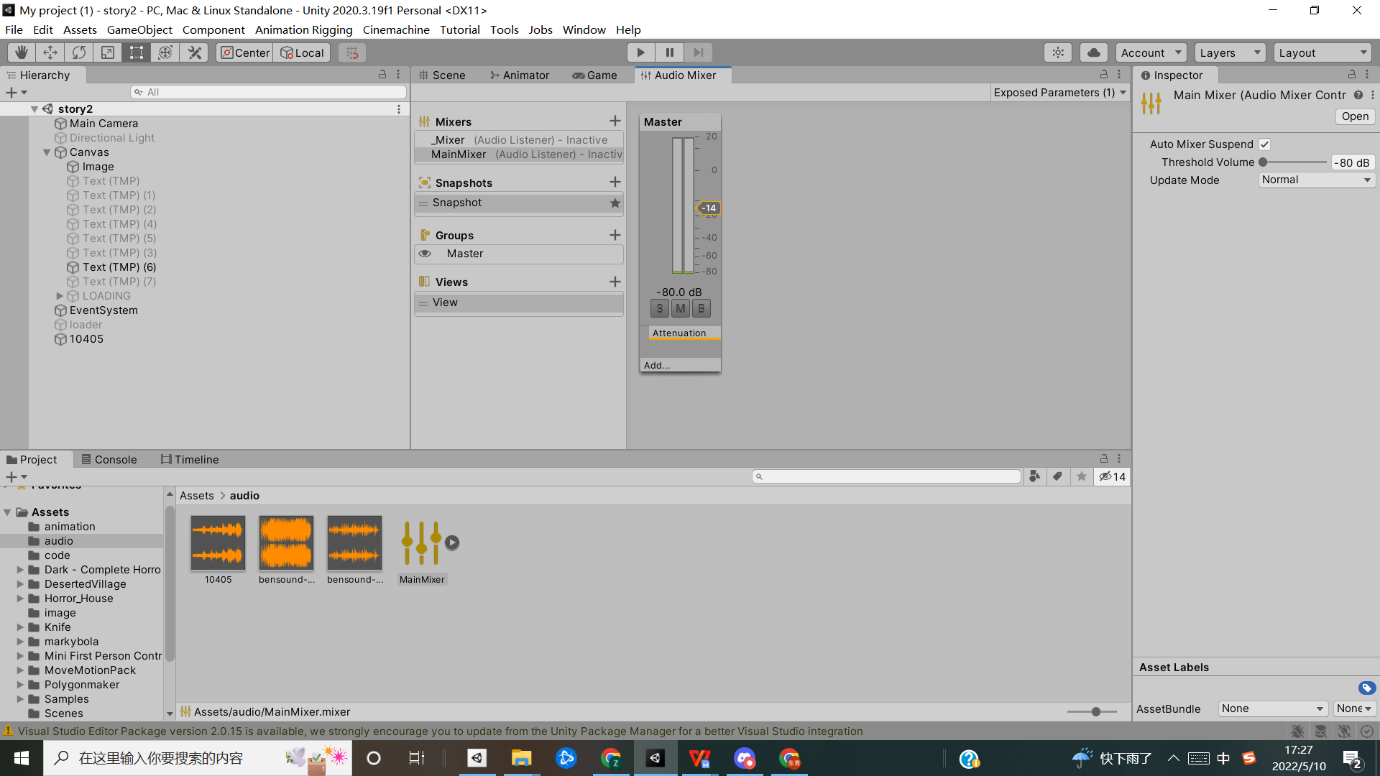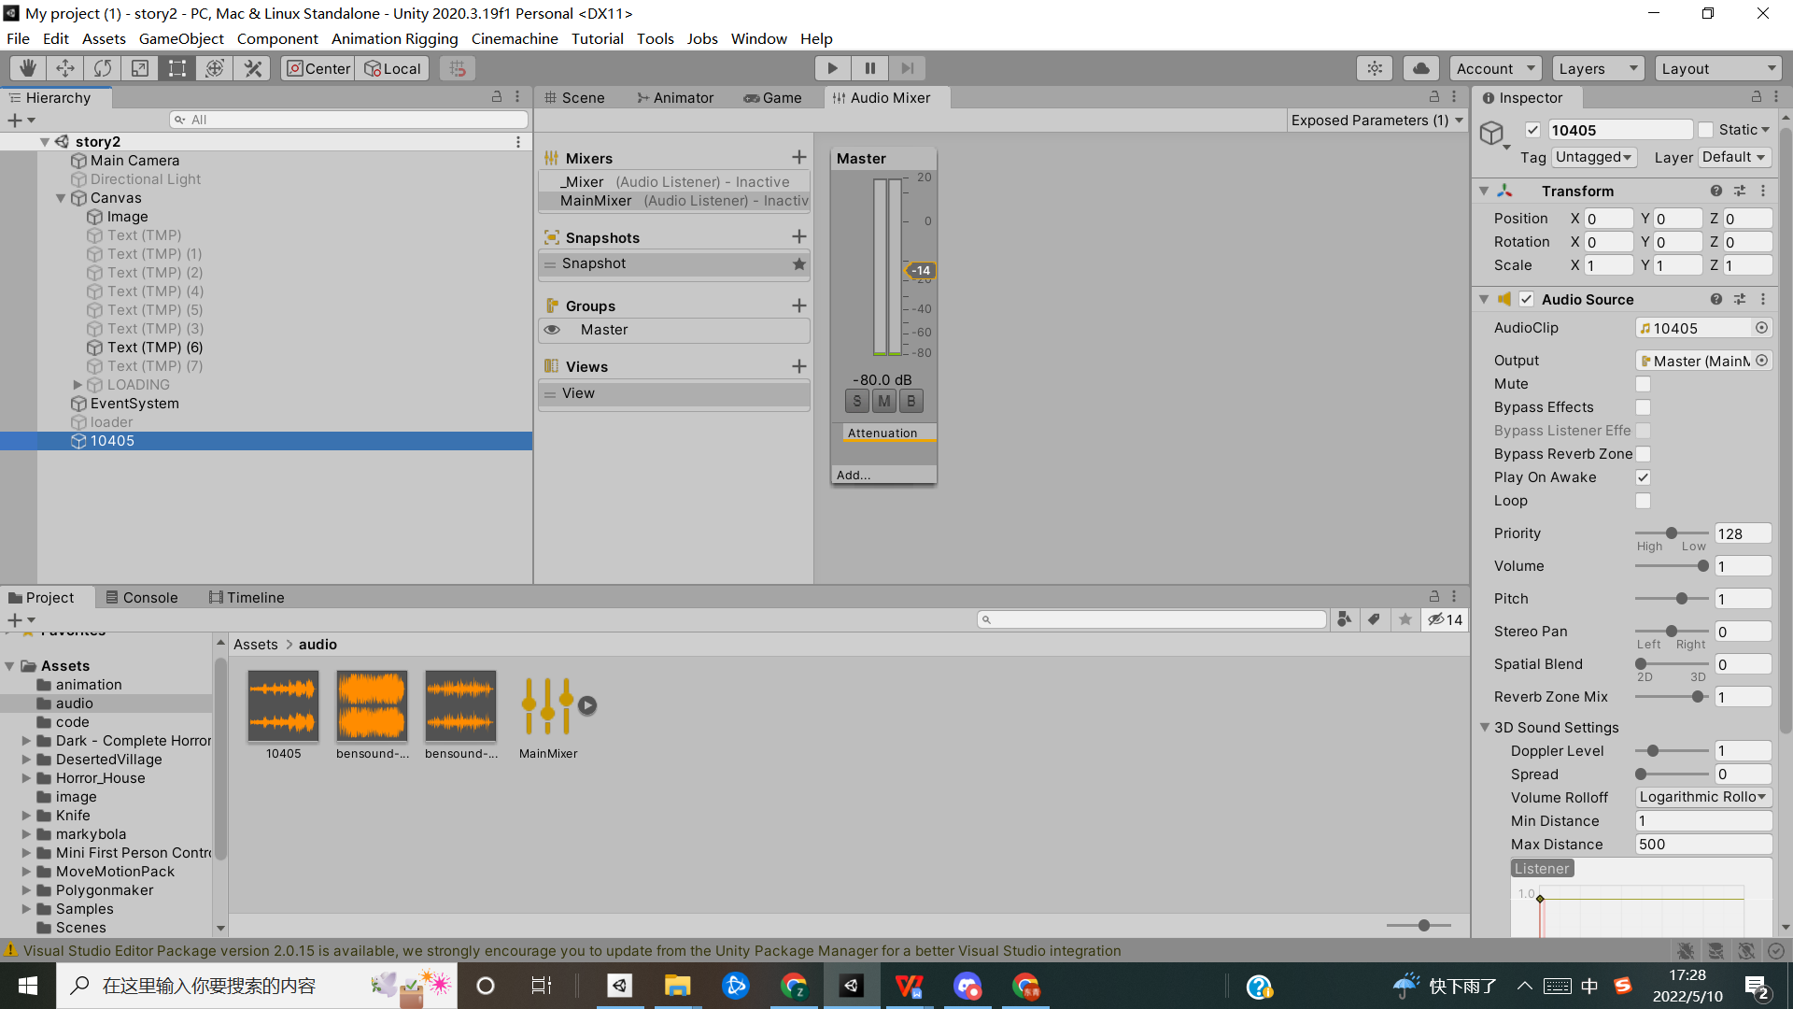

*Figure 16:Audio mixer*

Audio mixer is a function that allows controlling the volume of the game through the game interface. Mixter is used in conjunction with an audio source. The designer can add the created master to the audio source's output and connect it to the slider in the GUI via code so that the player can control all the game volumes from the operator interface.

It should be noted that during the setup process, the right mouse clicks on the volume on the inspector. Then click on the Expose option so that the parameters are exposed.

4.3.7 script

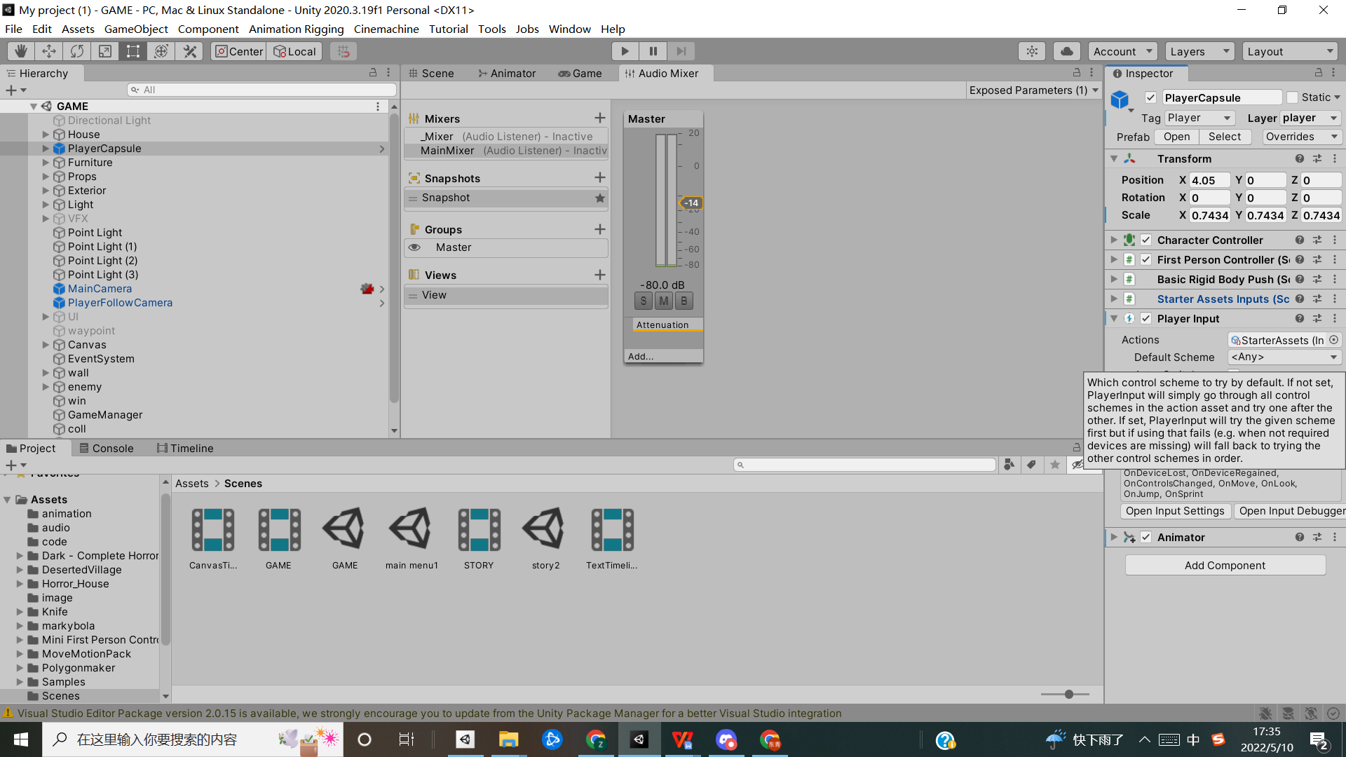

*Figure 17:Script*

In Unity the designer is able to drag and drop the code directly to the bottom of the inspector after it has been created. Below are some examples of the code.

1. Chase

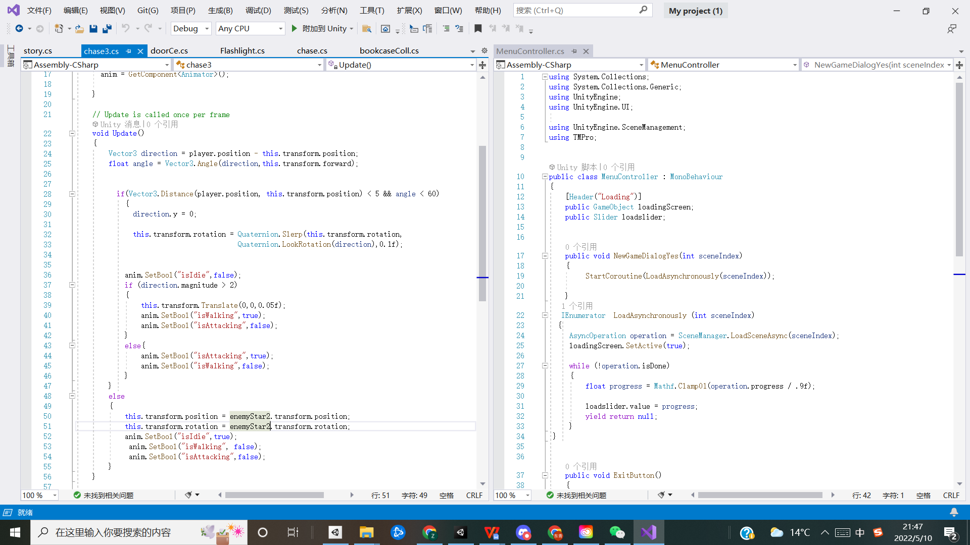

*Figure 18:ScriptChase*

The main function of this part of the code is that the enemies play different animations depending on their distance and angle from the player and return to their original position when they collide with the door.

The code uses if, else logic to split the distance to the player into different cases, and uses anim.setbool to call the animator animation.

2.detectHit

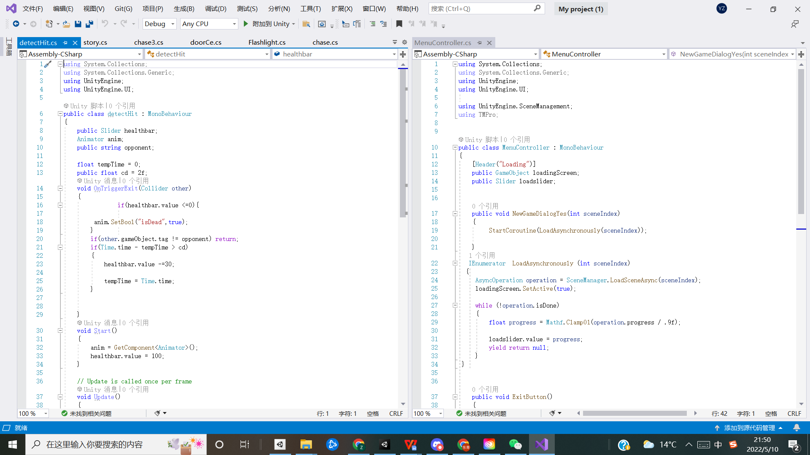

*Figure 19:ScriptdetectHit*

The main function of this part of the code is to control the player's blood level, and the player dies when the player's life level is 0.

The code uses the On TriggerExit method to determine if the trigger has been exited, and sets the cd time to prevent the enemy's damage from leaving multiple times in a short period of time.

# Project Method

## Below introduces the methodology used in the production of the game

## Agile Software Dvelopment Method

Based on the research, selecting the appropriate method to complete the project could increase the completion efficiency to a certain extent,. The Agile software development method was chosen to be used for this project. According to Cockburn A and Highsmith J (21), it is based on the values and principles defined in the Agile Manifesto and is an umbrella term for a range of methods and practices. The fundamental principles of values espoused by agile experts are as follows (22)：

- Individuals and interactions over processes and tools

- Working software rather than comprehensive documentation

- Customer collaboration over contract negotiation

- Responding to change rather than following a plan

Pekka Abrahamsson, Outi Salo, Jussi Ronkainen, and Juhani Warsta (23) argue that lightweight and agile methods focus on simplicity and speed, quickly gathering feedback to react to incoming information. Rapid response is achieved by adding different requirements to the to-do list in the kanban broad on GitHub every time, constantly testing and discussing them regularly with supervisors to get feedback.

## Compare

There are other alternative approaches when developing software, such as Waterfall. The traditional waterfall development is the process from requirements to design, design to coding, coding to testing, and testing to release（24）. Probably, it requires the best at every stage of development and therefore demands more from the team, especially in the early stages: the more perfect the design, the less cost loss after submission. M McCormick （25）suggests that a company using this model spends much time at each stage of development until all doubts are removed, all requirements are met, and much time is spent on initial design work to correct errors in advance.

Hence, it is a more cumbersome approach than the agile approach, the sense of lack of efficiency, stability, and flexibility.

Agile development could have a shorter cycle time and emphasise a high level of collaboration within the team.

### Waterfall model advantage

1.Easy to prepare

Each phase has very specific deliverables and a specific review process when using waterfall project management. Since each phase has been well thought out, you always know where you want to go next, making it easy to make progress.

2.Suitable for small, simple projects

Since the Waterfall model is based on strict, established steps, it is better suited to managing simple projects with fixed deliverables. The deliverables of these projects usually do not change, and each phase can be seamlessly integrated.

3.Easy to use

Based on fixed project management principles, waterfall project management is much easier to understand and adopt. As a result, teams do not need to learn and adapt to it.

### Waterfall model disadvantage

1. A large amount of documentation during the development process, which greatly increases the workload

2.The fact that the results are only presented to the client at a later stage of the project increases the risk of the project development (e.g., if the project turns out to be very different from the client's expectations, fixing it will cause delays and increase costs);

1. The high cost of changes to requirements (changes to requirements are theoretically implemented in strict accordance with the various phases, resulting in high time costs);

### Agile software development method advantage

1.The milestones can be checked by the client during the development process, thus reducing the risk of project development;

2. Flexibility, changes to requirements can be made at any time.

3. Effective and motivated teams

There is a strong focus on people and collaboration in agile project management. This allows developers to be highly motivated, and the team always has clear responsibilities to drive the project forward actively.

4.More efficient processes

In agile project management, the Sprint review at the end of each iteration allows the team to review what went wrong and what could be improved.

In this way, the team can learn from the early processes and apply this knowledge to the next Sprint.

5.Better accountability

Both the team and the customer know exactly what has been done, what is being developed, and what the next step is planned. In addition, they both monitor the development work and provide feedback, which ensures that everyone in agile project management can be held accountable for their work.

### Agile Software development method disadvantage

1. Not suitable for small projects

In agile project management, there is a greater reliance on dividing projects into smaller cycles. However, if the project itself is small, there is no point in trying to divide it further.

2.Easy to get sidetracked

Agile project management can be very flexible in responding to changing customer needs, but the product development cycle can continue indefinitely until it goes off track.

### Part 2 Difference

1.Differences in workflow

In waterfall project management, there is only one development cycle. The project is not split into multiple Sprints or iterations. Once the client's requirements have been confirmed, work on the entire project can start.

In Agile project management, the development process is split into multiple cycles, and each Sprint needs to be completed and approved by the client before moving on to the next Sprint.

2.The difference in flexibility

Waterfall project management's process at each stage is carefully planned and rigorous at the start, so it cannot handle changing client requirements, let alone expand as the project progresses.

Agile project management splits the project into multiple development cycles. Since the entire project is not completed at once, there are multiple opportunities to apply user feedback to the rest of the development process.

3.Differences in the testing process

In waterfall project management, it is only necessary to test the product once the entire development work has been completed. This allows the product to be developed without disruption but can also end up causing massive problems.

In Agile project management, the project is reviewed and tested after each Sprint, which helps to fine-tune the details of the project and ensure that it always meets the customer's needs.

4.The difference in teamwork

In waterfall project management, the team is a very structured unit, with the project manager controlling the entire process. Most team members have clear roles, and each does their part.

In Agile project management, while there is a product owner and project manager to guide the team, most team members are self-sufficient and cross-functional, which allows them to adapt quickly to project changes.

5.The difference in customer involvement

In waterfall project management, your customer is only involved in the early stages of the project and the project's delivery phase, with less intervention during development.

In Agile project management, the client's input will be present throughout the project.

## Conclusion

There are qualitative differences between the different development methods, but Agile is generally the more appropriate method for the project. It is essential to prevent problems from occurring， to be able to solve them at minimal cost when they do occur.

According to McCormick M（26）, it is indeed profitable to use an agile model for smaller projects. For larger projects, it is not easy to judge the amount of work and time required for that project's Software development lifecycle. This game project, developed by a single person, is smaller, so the agile method is appropriate.

## Sprint

Agile methodologies, in particular Scrum, which is a variation of Agile used specifically for software development.

Scrum is a product management framework that uses teams of around seven people, each with their own role; Scrum provides a clear structure for team members, meetings and rules; these teams work in one to two week periods called Sprints, these sprints usually last around one to two weeks but never more than a month, and the goal of each Sprint is to build deliverable product increments（26）.

Scrum is a management process that focuses on software development using incremental and empirical methods. With an emphasis on management and teams, and open lines of communication; it is a very simple framework for complex software development projects and enables teams to organise themselves and make changes quickly.

## Project plan

This project used Scrum to create a requirements list, including a 3.1 requirements list and a report and split the contents of the requirements list into sections. Then, I created a kanban board on GitHub and divided it into four categories (To do, In progress, In review, Done) on the kanban board and worked on it. After, Work for two-week periods and have meetings with the supervisor. The position of the tasks on the kanban board is adjusted according to the progress and feedback. The picture below shows the application of the approach.

Week 1

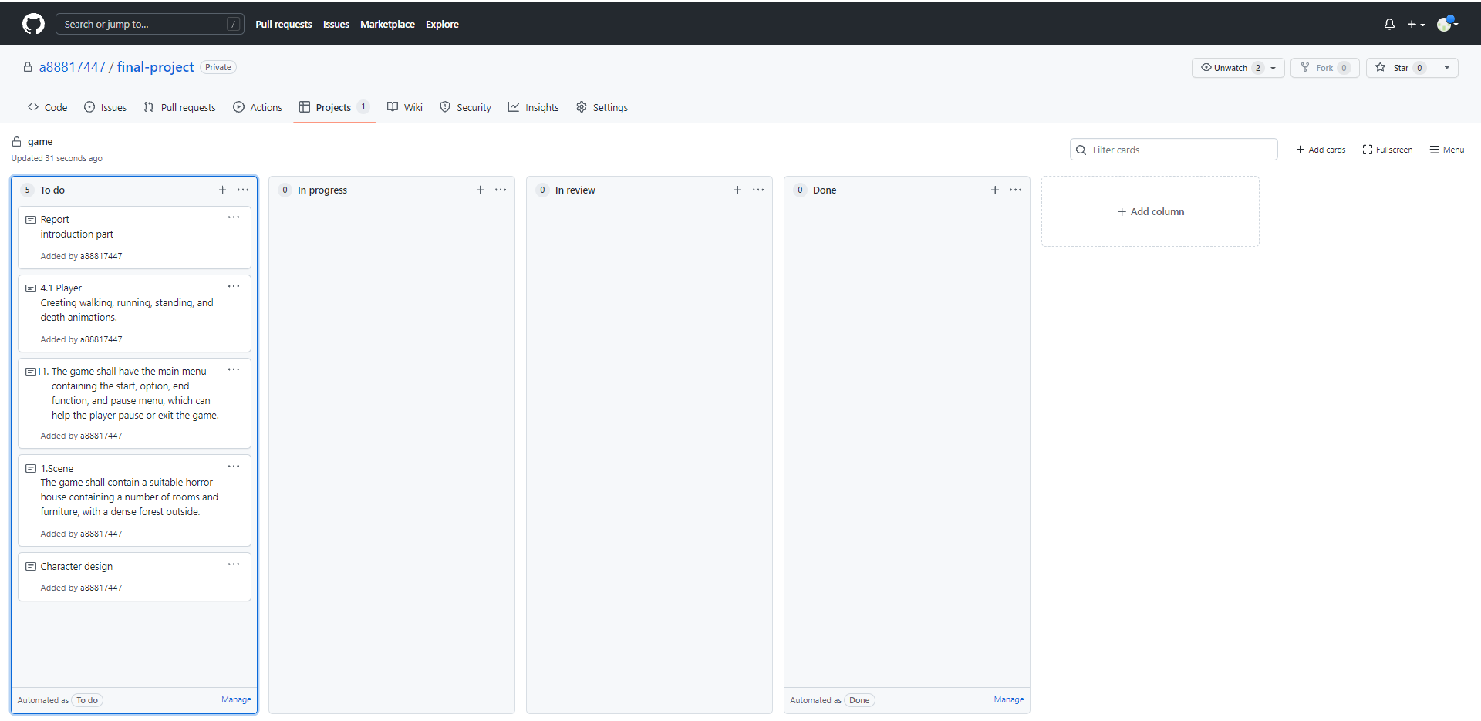

*Figure 20:Kanban week1*

Final week

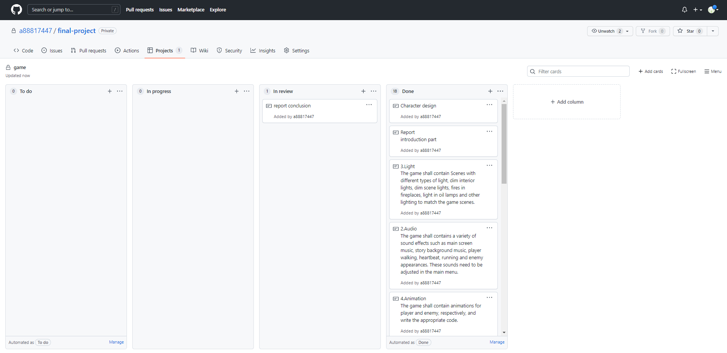

*Figure 21:Kanban last week*

# User Test

This section contains feedback and analysis of user testing. It also includes a self-assessment of whether the game requirements are achieved.

## Aim

As the game's development is essential to the user experience, I would like some way to discuss the game's progress and prospects with potential players and the general public. The purpose is to get feedback from players to keep it on track and brainstorm on several features that could be improved.

## Methodology

I have chosen to use the questionnaire method making players experience the game online at zoom. Generally speaking, questionnaires are more detailed, complete and easier to control than interview forms. The main advantages of the questionnaire method are standardisation and low cost. Because the questionnaire method is conducted with a designed questionnaire instrument, the design of the questionnaire requires standardisation and measurability. The questionnaire method is one of the more widely used methods in social surveys, both nationally and internationally. A questionnaire is a form used for statistical and survey purposes that formulates questions in the form of a set of questions. The questionnaire method is a way for the researcher to collect reliable information by using this controlled measure of the problem under study. In this questionnaire I used the Google online questionnaire to send the survey to the respondents. The answers were filled in by the respondents as asked in the form. The online questionnaire format ensured that the survey could still be conducted effectively during the epidemic and also increased the distribution of the questionnaire to a certain extent, gaining more feedback from players and making the user experience more informative and realistic.

## Survey Participants

The population surveyed about this game was mainly young people aged 18 and above, including experienced gamers such as AAA game fans, horror game fans, first Person Shooter game fans, but also light gamers and people who have never played the game before. It is hoped that this will satisfy the diversity of the sample. This questionnaire investigates several aspects of the game, including the basic interface, tutorials, basic operations, quest guidance, overall difficulty, monster design, overall game experience and post-play experience.

## Data Collection

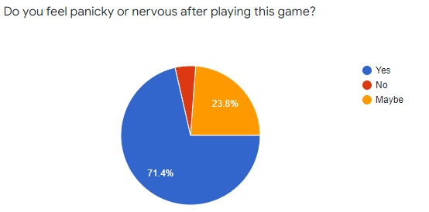

*Figure 22:question 1*

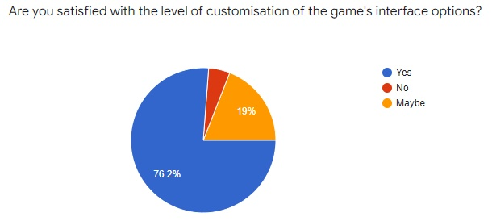

*Figure 23:question 2*

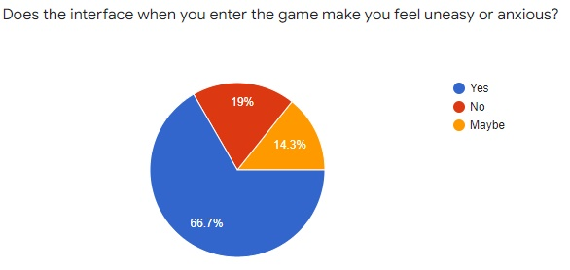

*Figure 24:question 3*

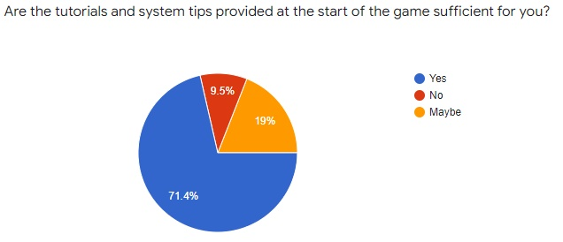

*Figure 25:question 4*

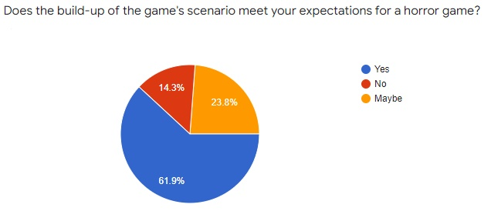

*Figure 26:question 5*

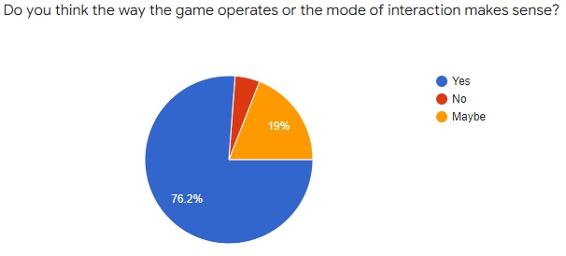

*Figure 27:question 6*

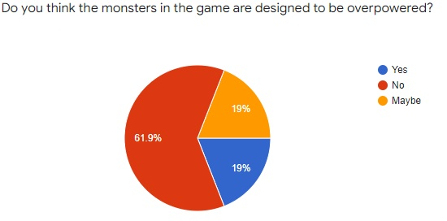

*Figure 28:question 7*

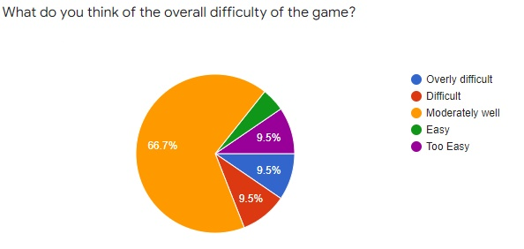

*Figure 29:question 8*



*Figure 30:question 9*

## Feedback

I have collected dozens of responses to the survey sent out for this game and also recorded feedback on the game through user dictation. A statistical analysis of these responses has yielded the following feedback.

## 1. The game's menu, loading, and basic screens are all reasonably well designed and have made a conscious effort to provide more customization options for the player to create a better-personalized gaming experience. However, there is still room for improvement, such as adding small features like screen resolution adjustment and HUD resizing.

2. The tutorial at the beginning of the game is a good reminder of what to do. This also makes it easier for players who have never played a horror or first-person game before to get the hang of the game.

3. The setting is built in a very traditional old-fashioned horror game atmosphere, with dim lighting, eerie woods, standing manor houses, and other elements that create a realistic atmosphere for the player. The fight against the unknown creates horrific scenarios in the mind that can happen at any moment. The player does not know how to protect himself in the darkness where danger lurks.

4. Leading on from the third point above, the mechanics in the game are exciting. Unfortunately, the player is not given any weapons, so the traditional first-person shooter experience does not work here. This leads to a deep sense of helplessness, effectively inducing a short-term panic attack.

## 5. The flashlight, the item provided to the player, does the opposite, effectively tantalising the player's imagination as they explore the abandoned and darkened rooms, dominating the player's inner anxiety and fear of the unknown even deeper. The player will never know what will happen next, worrying the player. Even when the player finishes the game, they will not know what they should expect.

## 6.The Enemies in the game are well designed, but the downside is that the enemy variety is relatively homogeneous. Since the player is not given a weapon, the player cannot initiate an attack on the enemies. Moreover, while this can certainly go a long way in strengthening the fear in the player's mind, overpowered enemies can also lead to exhaustion and frequent deaths. This indirectly leads to frustration in the player's mind, affecting interest in the game. This part of the game has a good numerical design. The enemy attacks give the player at least four blood hits under normal circumstances. Enemy attacks have a long forward swing for the player to react.

7. The presence of the blood bar mechanic, but the game's lack of a prop system means that the player's blood cannot be restored or boosted by picking up props. The result is that the player's blood bar is more similar to Mario's mechanics. This makes the player even less forgiving. Hopefully, the prop mechanic can be followed up with a supplement.

8. After a complete playthrough, there are no major problems with the general framework and logical design of the game. There is still room for improvement in implementing some minor designs and features. Overall, the unsettling atmosphere of the game and the fact that the player does not know what to do or what to expect makes the game passable as a horror game. However, the game's plot performance and storytelling are still lacking and short. The game is also relatively short, leading to a slightly less immersive and unfulfilling experience.

Problems have also arisen during the project, such as crashes in the recorded data, which may affect the results.

**6.5 Requirements Review**

In this section, I self-assessed whether my game fulfilled the content presented in 3.1 Requirements.

For storyline requirement, i have completely achieved all requirements except audio and npc through playtesting, the npc requirements have not been achieved at all and the audio requirements have only been achieved Background music and story plot music.

For Desirable requirement,The project fulfils the need for a minimap, as the game has a difficulty setting where the player does not achieve the victory condition after death, the player might choose to try again. So it also partially fulfils the need to encourage players to play multiple times.

# Conclusion

This section will describe the results of the project. We use user feedback and self-assessment to determine future work for the project and propose a new alternative approach at the end.

## Result

The main goal of this project was to create a 3D interactive game with a horror theme, the atmosphere was created, and the game mechanics were satisfactory to most of the testers. With the basic requirements completed, the project needed to add more complex project features to enhance the player experience to a greater extent. In addition, the game experimented with some content in terms of embodied storyline, which could have been enriched.

Overall as a horror 3D game, it is a success in terms of visuals and essential features, while the game's complexity needs to be further improved.

## Further Work

The limitations of this game are that there are no suitable scenarios for the plot I have built. With more time, budget and staff, I would like to build scenarios that fit the plot better and expand the range of activities available to the player, such as increasing the size of the rooms and adding more interactive rooms. I had similar problems with the characters, as due to the lack of free horror material, the characters I chose were not more relevant to the plot and only had one type of enemy. I would also like to add my animations, such as enemies that sleep and doze off to chase the player.

I would suggest that more features and difficulty could be added to the game in the future. In addition, a horror template could be created based on the optimisation of the game, saving subsequent developers much time to customise their horror games by simply changing scenes and materials.

## Alternative Methodologies

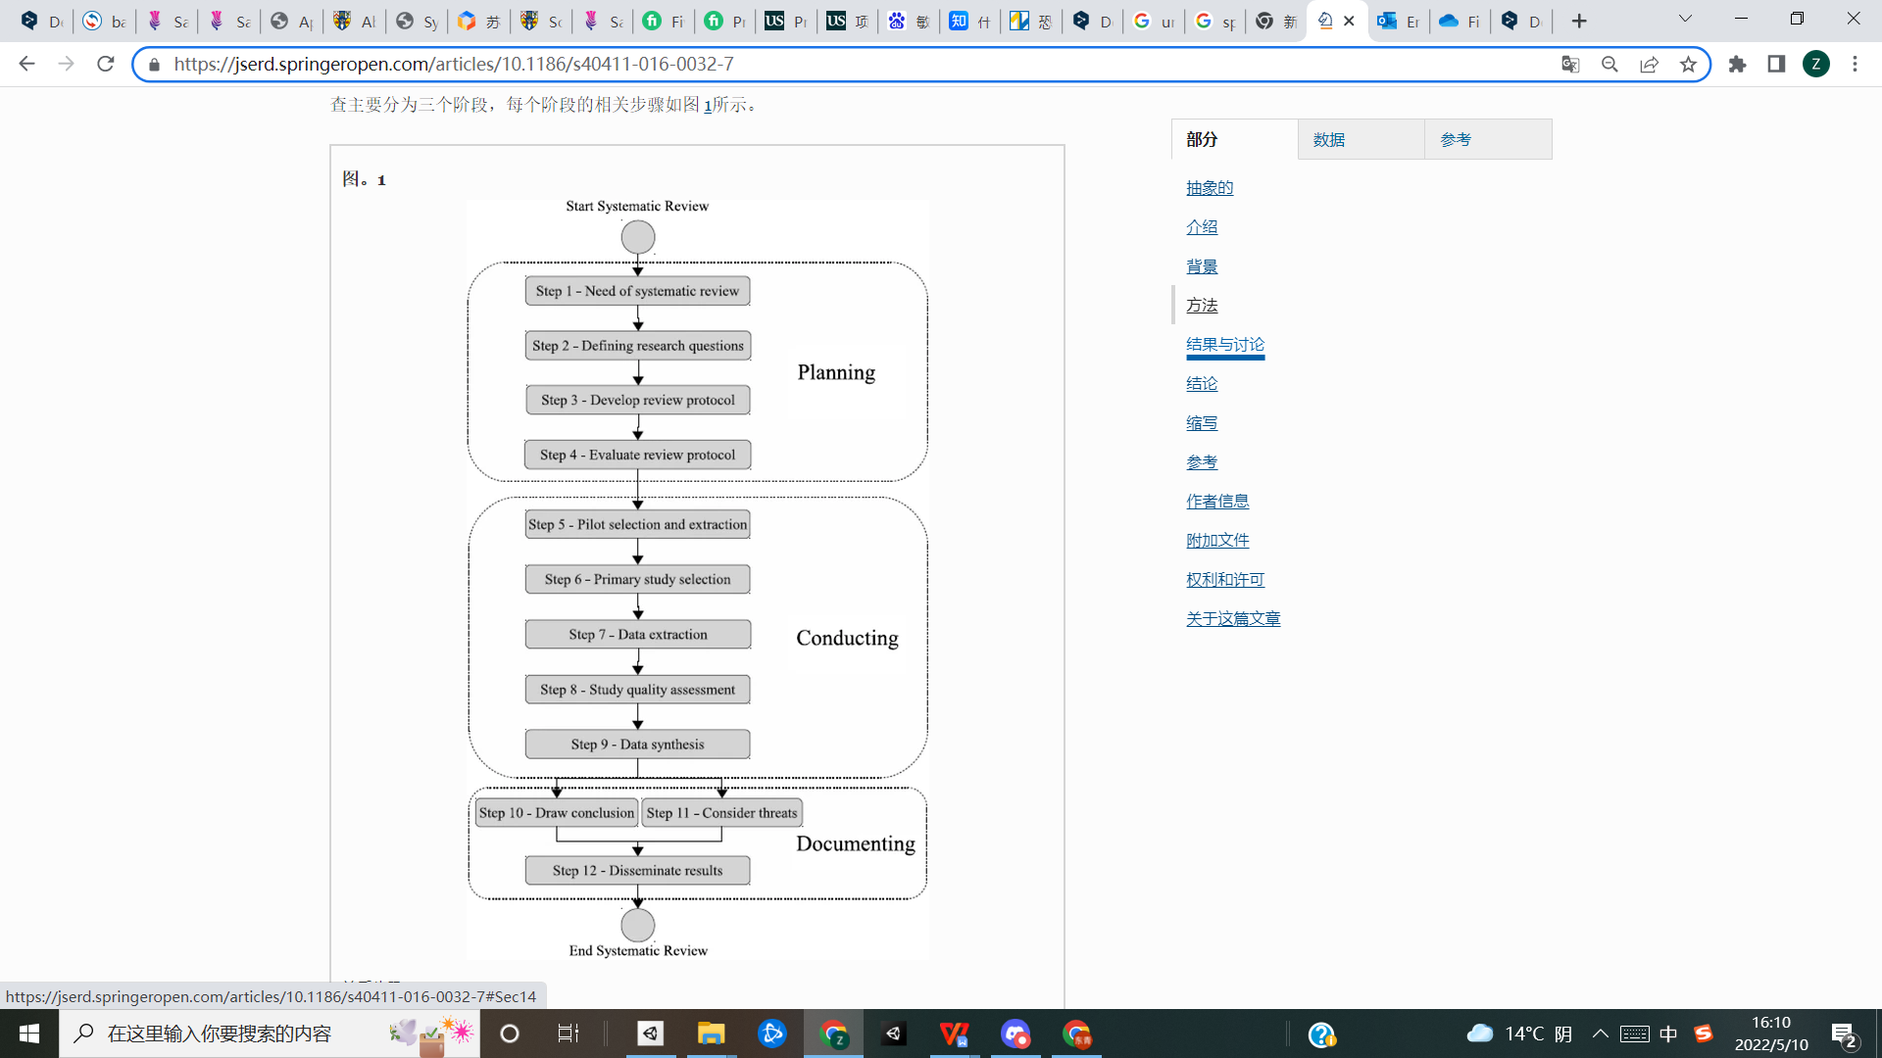

*Figure 31:GDSE*

There is another way of combining the agile and waterfall approach called GDSE. All phases of the GDSE process lifecycle can be combined into three main phases: pre-production, production, and post-production. The pre-production phase involves testing the feasibility of the target game scenario, including the requirements engineering marketing strategy; the production phase involves planning, documentation, and implementation of the game scenario with sound and graphics. The final stage of post-production involves testing, marketing, and game advertising.（27）

# Professional and Ethical Considerations

## BCS Code of Conduct

## Should be independent put code

## PUBLIC INTEREST [13]

**1. Have due regard for public health, privacy, security, and wellbeing of others and the environment;**

There will be some horror elements such as lighting, sound effects, and scenery images. However, the game will avoid causing discomfort to the player, such as mosaics on scary images or warnings before scary sound effects, and it will also limit the player's age to 18 years or older.

**2. Have due regard for the legitimate rights of third parties;**

Third parties are free to use the resources associated with the project and the project itself, and the creators will be adequately attributed.

**3. Conduct your professional activities without discrimination on the grounds of sex, sexual orientation, marital status, nationality, colour, race, ethnic origin, religion, age or disability, or of any other condition or requirement;**

The main activity of the participant is to control the character to play the game, and no discriminatory content will be added to the game. Moreover, no discriminatory communication will be made while the player is playing.

**4. Promote equal access to the benefits of IT and seek to promote the inclusion of all sectors in society wherever opportunities arise;**

Create equal conditions for everyone, including older people and people with disabilities, to reduce the disadvantages of not using it like everyone else.

## PROFESSIONAL COMPETENCE AND INTEGRITY

**4. Ensure that you have the knowledge and understanding of legislation and that you comply with such legislation in carrying out your professional responsibilities;**

Once the game's theme content is nearly complete, it will be graded based on the Pan-European Game Information [PEGI] (3/7/12/16/18) when released in Europe. The USK [Entertainment Software Self-control] (0/6/12/16/18) in Germany, Europe is required to grade the game.

**5. Respect and value alternative viewpoints and seek, accept and offer honest criticisms of work;**

Before the game is released, a test version must be submitted on the platform, and questionnaire feedback on the game quality must be truthfully released as scheduled.

**7. Reject and will not make any offer of bribery or unethical inducement.**

Entrained personal beliefs, religions, hints, and other leading factors will not appear in the game. Moreover, all the feedback shall be collected and submitted truthfully.

## Ethical Review

**1. Participants were not exposed to any risks greater than those encountered in their normal working life.[14]**

The project is a horror video game with potential risks. It contains bright or flashing lights, loud or disorienting noises.

**2. The study materials were paper-based or comprised of software running on standard hardware.**

Participants need to experience the game on my or their pc device and then leave feedback on their phones, i-pads, and computers.

**3. All participants explicitly stated that they agreed to participate and that their data could be used in the project.**

Participants will be informed of the main contents of the test and that the results of the follow-up evaluation are likely to be used after the project period.

**4. No incentives were offered to the participants.**

Participants are volunteers and will not receive any benefits.

**5. No information about the evaluation or materials was intentionally withheld from the participants.**

Participants will not have full access to all of the game's plot and content when playing the game. They will need to explore it independently, so there will be some concealment, but participants will be informed beforehand. If they have any questions or do not wish to participate before the experience, any such cases will be answered, and they can withdraw.

**6. No participant was under the age of 18.**

The participants are university students and are all over 18 years old.

**7. No participant had a disability or impairment that may have limited their understanding or communication, or capacity to consent.**

The participants are university students, and the user research will occur during working hours.

**8. Neither I nor my supervisor is in a position of authority or influence over any participants.**

The identity of the participants will not be revealed to anyone, and the participants are my classmates. My supervisor will not influence this user survey, and the questionnaire will be filled in anonymously.

**9. All participants were informed that they could withdraw at any time.**

As this is a horror-type game project, participants are likely to drop out before or during the experience and will be informed in advance that they can do so at any time.

**10. All participants have been informed of my contact details and the contact details of my supervisor.**

During the briefing and debriefing, participants will be provided with a note or message containing the email addresses of me and my supervisor.

**11. The evaluation was described in detail to all of the participants at the beginning of the session, and participants were fully debriefed at the end of the session. In addition, all participants were given the opportunity to ask questions at both the beginning and end of the session.**

Participants will be provided with answers to frequently asked questions and I will be available to answer any relevant questions.

**12. All the data collected from the participants is stored securely and in an anonymous form.**

Data collected from participants is stored on my password-protected mobile phone or computer and cannot be edited.

Due to some scary elements, the project will only be user tested on adults without any relevant psychological disorders. They will be informed in advance of factors that may cause discomfort.

# References

1. WhatIs.com. 2021. What is 3D gaming? - Definition from WhatIs.com. Available at: <https://whatis.techtarget.com/definition/3D-gaming>.
2. Technologies, U., 2021. The difference between 2D and 3D games in Unity. Unity. Available at: <https://unity.com/how-to/difference-between-2D-and-3D-games#characteristics-3d-video-games>
3. Games, R., 2021. Rockstar Games. Rockstar Games. Available at: <http://www.rockstargames.com> .
4. CD PROJEKT RED. 2021. CD PROJEKT RED - The industry leader in creating role-playing games. Available at: <http://en.cdprojektred.com>.
5. Nintendo of Europe GmbH. 2021. Offizielle Nintendo Deutschland-Seite. Available at: <http://www.nintendo.de>.
6. Havok. 2021. Havok. [online] Available at: <https://www.havok.com/>.
7. Game Developer. 2021. Better Games Through Usability Evaluation and Testing. Available at: <https://www.gamedeveloper.com/production/better-games-through-usability-evaluation-and-testing> .
8. Fronczak, T., 2021. 8 Types of Game Design Engines Worth Knowing. Animation Career Review. Available at: <https://www.animationcareerreview.com/articles/8-types-game-design-engines-worth-knowing>
9. GitHub. 2021. P3D/markingCriteria.md at master · glowkeeper/P3D. [online] Available at: <https://github.com/glowkeeper/P3D/blob/master/docs/assignment/markingCriteria.md> [Accessed 11 November 2021].
10. Legal.ubi.com. 2021. Consumer Information. Available at: <https://legal.ubi.com/disclaimers/en-US>.
11. Millp, J., 1994. Video Game-Induced Seizures. Pediatric Neurology Briefs, 8(9), p.68.icha

12.Jamie K King. An Analysis of the Methods and Techniques Used to Create an Unsettling Atmosphere in Horror Games, 2015.

13.Bcs.org. 2021. Available at: https://www.bcs.org/

14.Graja, S., Lopes, P. and Chanel, G., 2021. Impact of Visual and Sound Orchestration on Physiological Arousal and Tension in a Horror Game. IEEE Transactions on Games, 13(3), pp.287-299..

15.McKettrick, D., 2013. An Investigation into the Effects of Horror Games. Gamecareerguide.com. Available at: <https://www.gamecareerguide.com/features/1247/an_investigation_into_the_effects_.php?print=1> .

16.Suni, E., 2021. Sleepwalking - Causes, Symptoms, & Treatments - Sleep Foundation. Sleepfoundation.org. Available at: <https://www.sleepfoundation.org/parasomnias/sleepwalking>

17.Your Article Library. 2022. Questionnaire Method of Data Collection : Advantages and Disadvantages. [online] Available at: <https://www.yourarticlelibrary.com/social-research/data-collection/questionnaire-method-of-data-collection-advantages-and-disadvantages/64512>

18, Lynch, T. and Martins, N., 2015. Nothing to Fear? An Analysis of College Students' Fear Experiences With Video Games. Journal of Broadcasting &amp; Electronic Media, 59(2), pp.298-317.

19.Haggis, M., 2016. Creator’s discussion of the growing focus on, and potential of, storytelling in video game design. Persona Studies, 2(1), pp.20-25.Haggis, M., 2016. Creator’s discussion of the growing focus on, and potential of, storytelling in video game design. Persona Studies, 2(1), pp.20-25.

20.Hackr.io. 2022. [online] Available at: <https://hackr.io/blog/unity-vs-unreal-engine>

21.Cockburn A, Highsmith J. Agile software development, the people factor[J]. Computer, 2001, 34(11): 131-133.

22.Fowler M, Highsmith J. The agile manifesto[J]. Software development, 2001, 9(8): 28-35.

23.Abrahamsson P, Salo O, Ronkainen J, et al. Agile software development methods: Review and analysis[J]. arXiv preprint arXiv:1709.08439, 2017.

24.Balaji S, Murugaiyan M S. Waterfall vs. V-Model vs. Agile: A comparative study on SDLC[J]. International Journal of Information Technology and Business Management, 2012, 2(1): 26-30.

25.McCormick M. Waterfall vs. Agile methodology[J]. MPCS, N/A, 2012.

26.Hackr.io. 2022. [online] Available at: <https://hackr.io/blog/unity-vs-unreal-engine> [Accessed 9 May 2022].

27.Aleem, S., Capretz, L.F. & Ahmed, F. Game development software engineering process life cycle: a systematic review. J Softw Eng Res Dev 4, 6 (2016). https://doi.org/10.1186/s40411-016-0032-7

Figure：Red Dead Redemption 2. 2021. Red Dead Redemption 2. Available at: <https://www.rockstargames.com/reddeadredemption2/restricted-content/agegate/form?redirect=https%3A%2F%2Fwww.rockstargames.com%2Freddeadredemption2%2Fzh&options=&locale=zh_hans> .

**Audio**

Ofelia's dream

https://www.bensound.com/royalty-free-music/track/ofelias-dream

10405

https://sc.chinaz.com/yinxiao/topic_kongbuyinxiao.html

**Image**

Background image

https://www.teahub.io/viewwp/xiRmmh_moon-horror-halloweenstreet-backgrounds-hd-abstract-horror-house/

Skull

http://www.logosj.com/logo/1038.html

Flashlight cookie

https://tattletail.fandom.com/wiki/Flashlight

**Package**

# Basic Motions (Free Pack)

https://assetstore.unity.com/packages/3d/animations/basic-motions-free-pack-25900

[Dark - Complete Horror UI](https://assetstore.unity.com/packages/2d/gui/dark-complete-horror-ui-200569" \t "https://assetstore.unity.com/_self)

https://assetstore.unity.com/?q=complete%20horror%20ui&orderBy=1  
Deserted Village

https://assetstore.unity.com/packages/3d/environments/historic/deserted-village-86290  
Horror House

https://assetstore.unity.com/packages/3d/environments/horror-house-201322  
Mini First Person Controller

<https://assetstore.unity.com/packages/tools/input-management/mini-first-person-controller-174710>  
Starter Assets - First Person Character Controller

<https://assetstore.unity.com/packages/essentials/starter-assets-first-person-character-controller-196525>  
Interactions Animations

<https://assetstore.unity.com/packages/3d/animations/interactions-animations-195888>  
Basic Run Walk Movement animation package

https://assetstore.unity.com/packages/3d/animations/basic-run-walk-movement-animation-package-217235  
PBR Female Survivor

<https://assetstore.unity.com/packages/3d/characters/humanoids/pbr-female-survivor-49658>  
Zombie Fisherman

https://assetstore.unity.com/?q=zombie%20fisherma&orderBy=1

**Code**

Options menu

<https://www.youtube.com/watch?v=YOaYQrN1oYQ&t=553s>

Dialogue

https://www.youtube.com/watch?v=8oTYabhj248

Chase1,2,3 and detectHit

https://www.youtube.com/watch?v=gXpi1czz5NA&t=1126s

https://www.youtube.com/watch?v=nt55pxA7Snk&t=1257s

Loading

<https://www.youtube.com/watch?v=YMj2qPq9CP8&t=553s>

Pause

https://www.youtube.com/watch?v=JivuXdrIHK0

Game over

https://www.youtube.com/watch?v=VbZ9_C4-Qbo&t=509s

Main menu

https://www.youtube.com/watch?v=Cq_Nnw_LwnI

Flashlight

https://www.youtube.com/watch?v=OxkDLbvIGYI&t=79s

# Appendices

## Proposal

candidate number：236156

project supervisor：Dr Steve Huckle

project title：3D Horror survive Game

## PROJECT AIMS AND OBJECTIVES

In this project, I am expected to focus on producing the horror village environment with a controllable main character and Interaction with other objects such as items， enemies, NPCs. This project can enhance the understanding of unity and the coding ability of the producer. It can also Improve life happiness for players and popularize a special kind of mental health somnambulate, attracting more people's attention. The object proposal would contain primary objectives and extension goals. The following are primary objectives to be completed:

Scenes and sound effects with a horrible environment

A clear guide for beginners，including basic functions for some buttons and menu system with useful UI

The basic movement for the main character ，like running. walking. hiding. attacking，the character may not have the strong attacking ability so I would like to create more hiding ways to let him survive.

The enemy here suffers from somnambulism, so related skills will be designed, and a shop will be made that fits the theme， items will affect the life system in the shop.

This game will have a complete ending, escape or fail, if you fail, you can start all over again

The following are extension objectives to be completed:

Branch of the plot，different choices may affect the final result

Save and read function，which be chosen before different options

Achievement system： for example players spend less than setting time ，they would get some achievement and special props.

Can choose different difficulty settings

More special props in NPCs shop

## RELEVANCE

This project includes many skills in my degree couse，like programming for 3D and game design & development includes basic and further skills for unity，visual effects, and 3D modelling, which helps enhance more details of the project.

## RESOURCES REQUIRED

Unity asset store

Other stores provide similar resources

## PERSONAL WEEKLY TIME TABLE

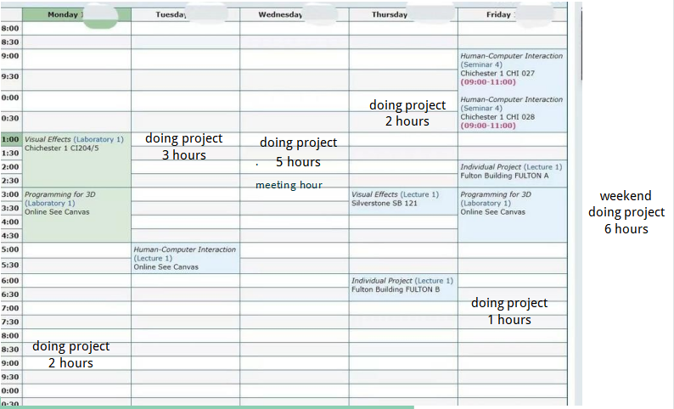

## BACKGROUND READING

3D graphics for game programming by JungHyun Han 2011

Creating eLearning Games with Unity by David Horachek 2013

## TIMELINE OF THE PROJECT

September 29 - initial meeting

October 11 - proposal

## User Testing Compliance Form



If the results of the evaluation are likely to be used beyond the term of the project (for example, the software is to be deployed, the data is to be published or there are future secondary uses of the data), then it will be necessary to obtain signed consent from each participant. Otherwise, verbal consent is sufficient, and should be explicitly requested in the introductory script (see Appendix 1).

No incentives were offered to the participants.

The payment of participants must not be used to induce them to risk harm beyond that which they risk without payment in their normal lifestyle. People volunteering to participate in research may be compensated financially e.g. for reasonable travel expenses. Payments made to individuals must not be so large as to induce individuals to risk harm beyond that which they would usually undertake.

No information about the evaluation or materials was intentionally withheld from the participants.

Withholding information from participants or misleading them is unacceptable without justifiable reasons for doing so. Any projects requiring deception (for example, only telling participants of the true purpose of the study afterwards so as not to influence their behaviour) are deemed high risk and require approval from the relevant C-REC.

No participant was under the age of 18.

Any studies involving children or young people are deemed to be high risk and require ethical approval through the relevant C-REC.

No participant had a disability or impairment that may have limited their understanding or communication or capacity to consent.

Projects involving participants with disabilities are deemed to be high risk and require ethical approval from the relevant C-REC.

Neither I nor my supervisor are in a position of authority or influence over any of the participants.

A position of authority or influence over any participant must not be allowed to pressurise participants to take part in, or remain in, any study.

All participants were informed that they could withdraw at any time.

All participants have the right to withdraw at any time during the investigation. They should be told this in the introductory script (see Appendix 1).

All participants have been informed of my contact details, and the contact details of my supervisor.

All participants must be able to contact the investigator and/or the supervisor after the investigation. They should be given contact details for both student and supervisor as part of the debriefing.

The evaluation was described in detail with all of the participants at the beginning of the session, and participants were fully debriefed at the end of the session. All participants were given the opportunity to ask questions at both the beginning and end of the session.

Participants must be provided with sufficient information prior to starting the session, and in the debriefing, to enable them to understand the nature of the investigation.

All the data collected from the participants is stored securely, and in an anonymous form.

All participant data (hard-copy and soft-copy) should be stored securely (i.e. locked filing cabinets for hard copy, password protected computer for electronic data), and in an anonymised form.

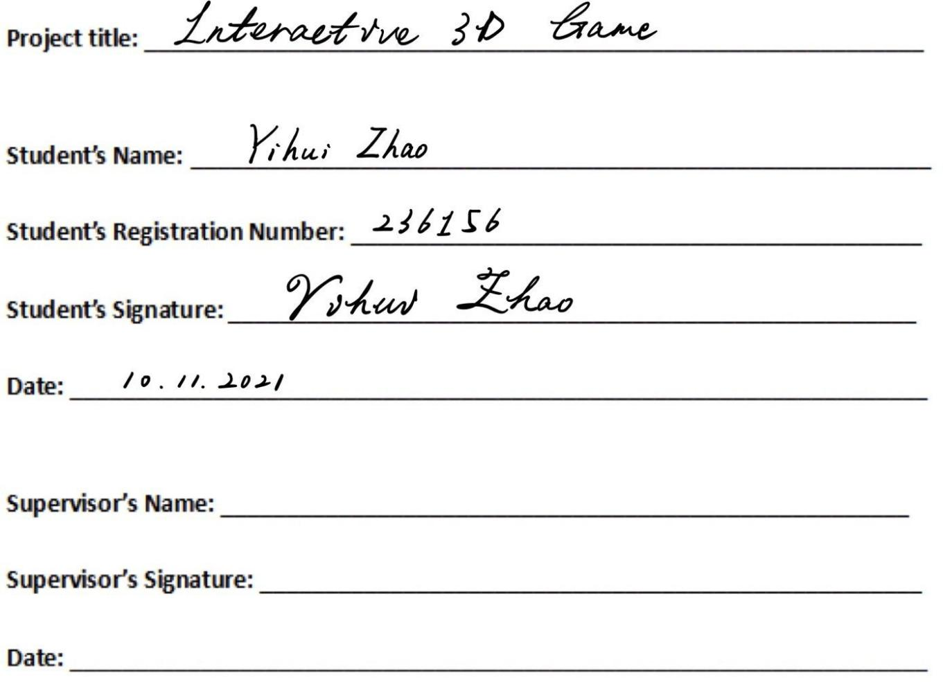

Dr Steve Huckle

10/11/2021

## Questionnaire

Reviews and feedback on the game

The questionnaire was designed to provide feedback and suggestions for improvements to the game's theme design.

1.Have you ever played a horror game in the same genre before playing this game?

Yes

No

2.Does the interface when you enter the game make you feel uneasy or anxious?

Yes

No

Maybe

3.Are you satisfied with the level of customisation of the game's interface options?

Yes

No

Maybe

4.Are the tutorials and system tips provided at the start of the game sufficient for you?

Yes

No

Maybe

5.Does the build-up of the game's scenario meet your expectations for a horror game?

Yes

No

Maybe

6.Do you think the way the game operates or the mode of interaction makes sense?

Yes

No

Maybe

7.Do you think the monsters in the game are designed to be overpowered?

Yes

No

Maybe

8.What do you think of the overall difficulty of the game?

Overly difficult

Difficult

Moderately well

Easy

Too Easy

others:

Do you feel panicky or nervous after playing this game?

Yes

No

Maybe

What do you think could be improved about this game?

Questionnaire on horror games

1. Have you ever played a horror game?*

Yes

No

2. Which of the following types of horror games do you like?*

Action horror （Like Resident Evil and Hunt: Showdown）

Psychological horror (Like Silent Hill and Layers of Fear)

AVG（Text adventure） (Like The song of Saya)

RPG（Role Play) (Like The Witch's House）

I don't like horror games.

3. Why would you play these games that bring you fear?*

Enjoy the excitement.

Challenge my guts.

I don't think it's scary, just that the horror element suits my taste.

Endure the horror elements in order to experience other aspects of the game.

others:

4. What do you find most appealing about horror games?*

Sense of atmosphere, especially music and art

The story and the emotions involved

The heartbeat of being scared

others:

5. What aspect of horror games do you find affects your gaming experience?*

Distorted picture due to technical problems or poor quality art.

Jump scare（The cheap trick of using sudden sounds or images to scare people）

Overly difficult chase battles

Overly complex maps

Too few operations

The decryption method is too homogeneous

Overwrought story line

others:

6. What do you think is the biggest difference in the experience of horror games compared to horror books and films?*

Operability

Immersion

Freely controlled in the boot

others:

7. In what ways do games fall short of other horror genres such as books and films?

8. What direction do you want horror games to go in the future?*

VR/AR

Open World

Cthulhu

others: